AMETFO Award Winners 2026

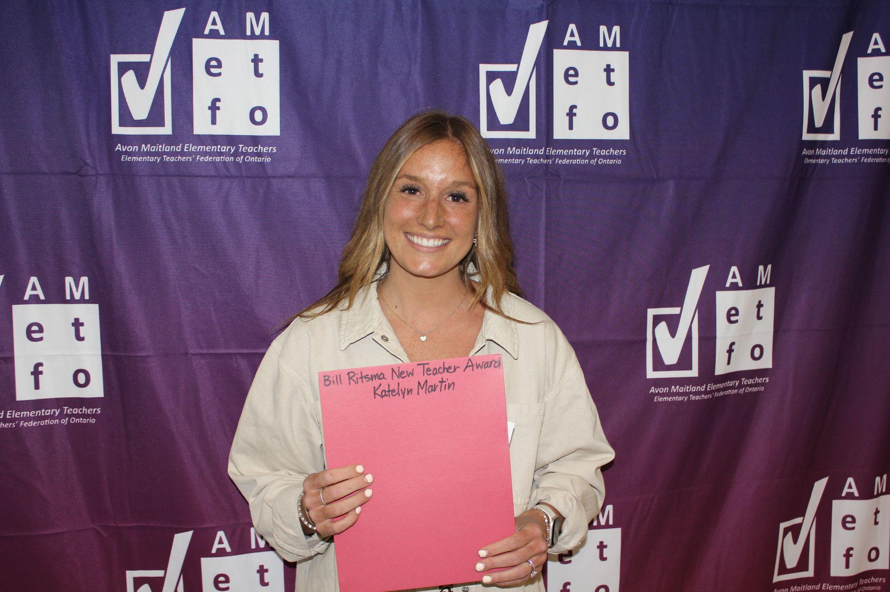 | 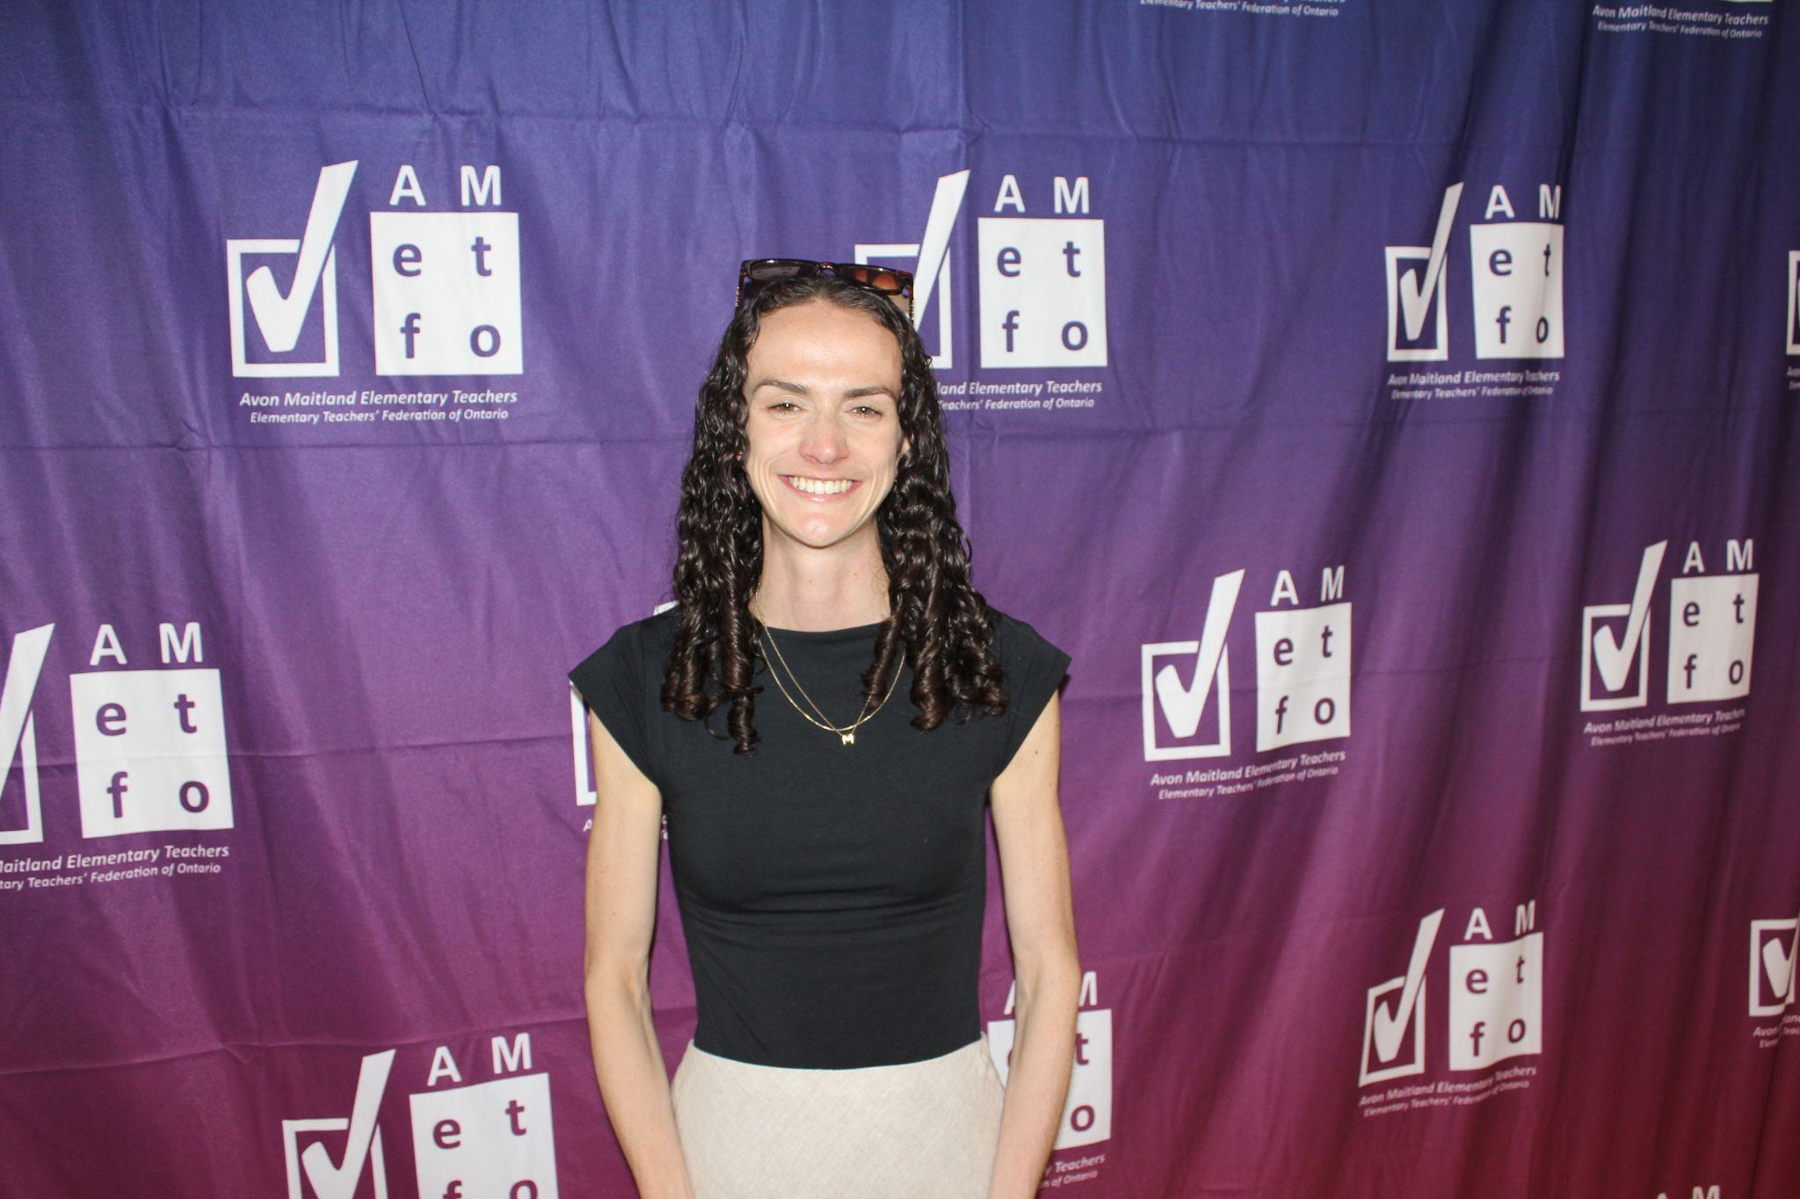
Bill Ritsma New Teacher Award  Katelyn Martin | Bill Ritsma New Teacher Award  Morgan Lewis
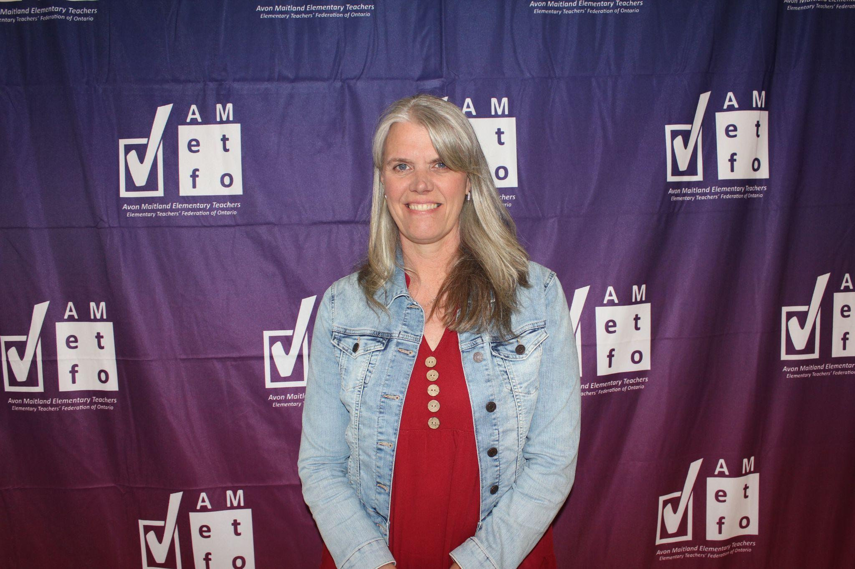 | 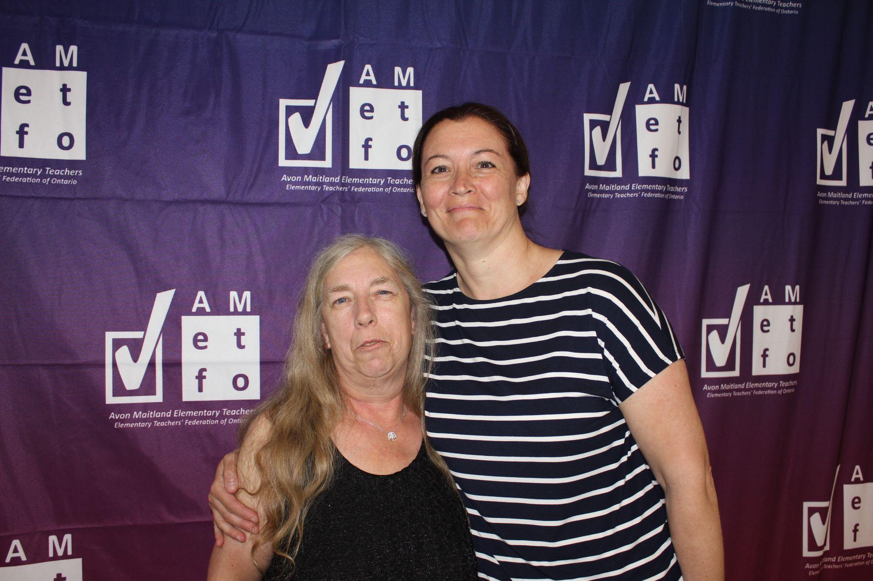
Humanitarian Award  Tara Brennan | Local School Supporter of Education  Sandy Schwartzentruber (left)

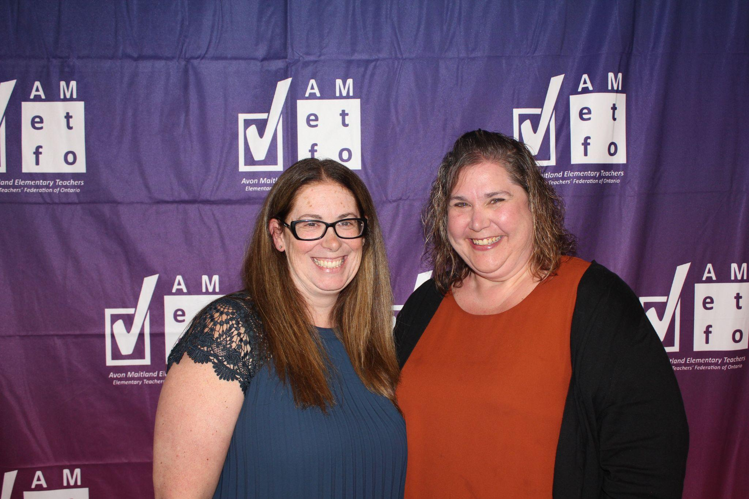 | 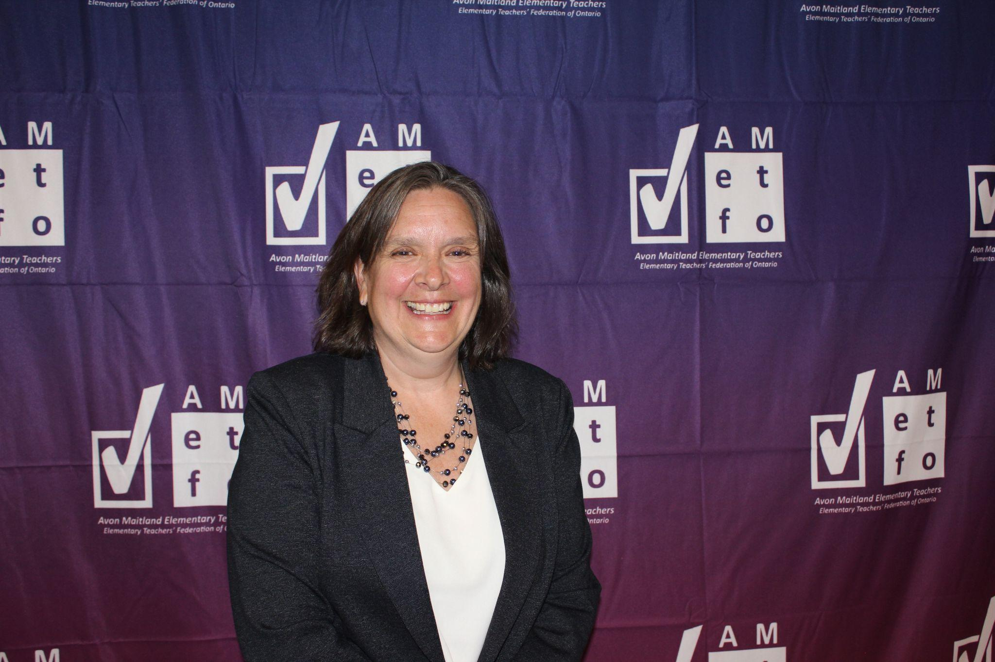
Local School Supporter of Education  Karen Gerretsen (right) | Mentor/Leadership  Jennifer Yantzi
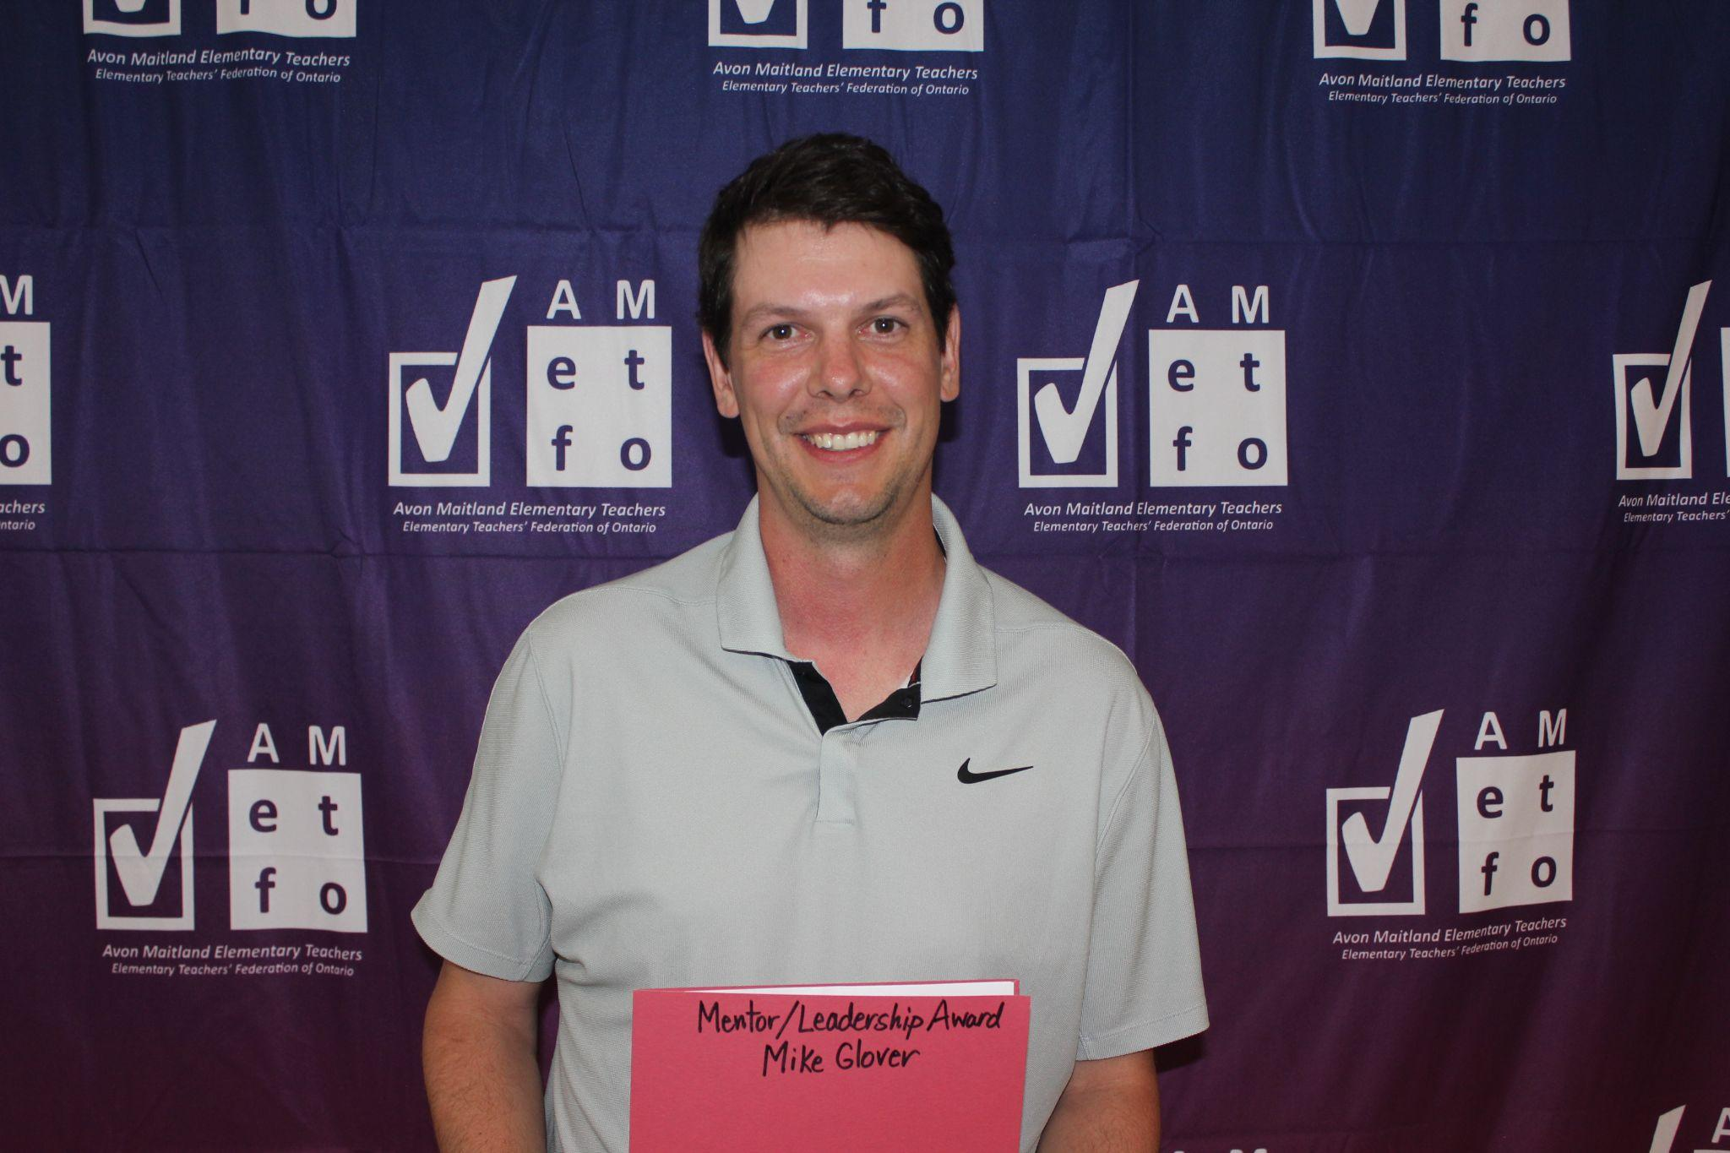 | 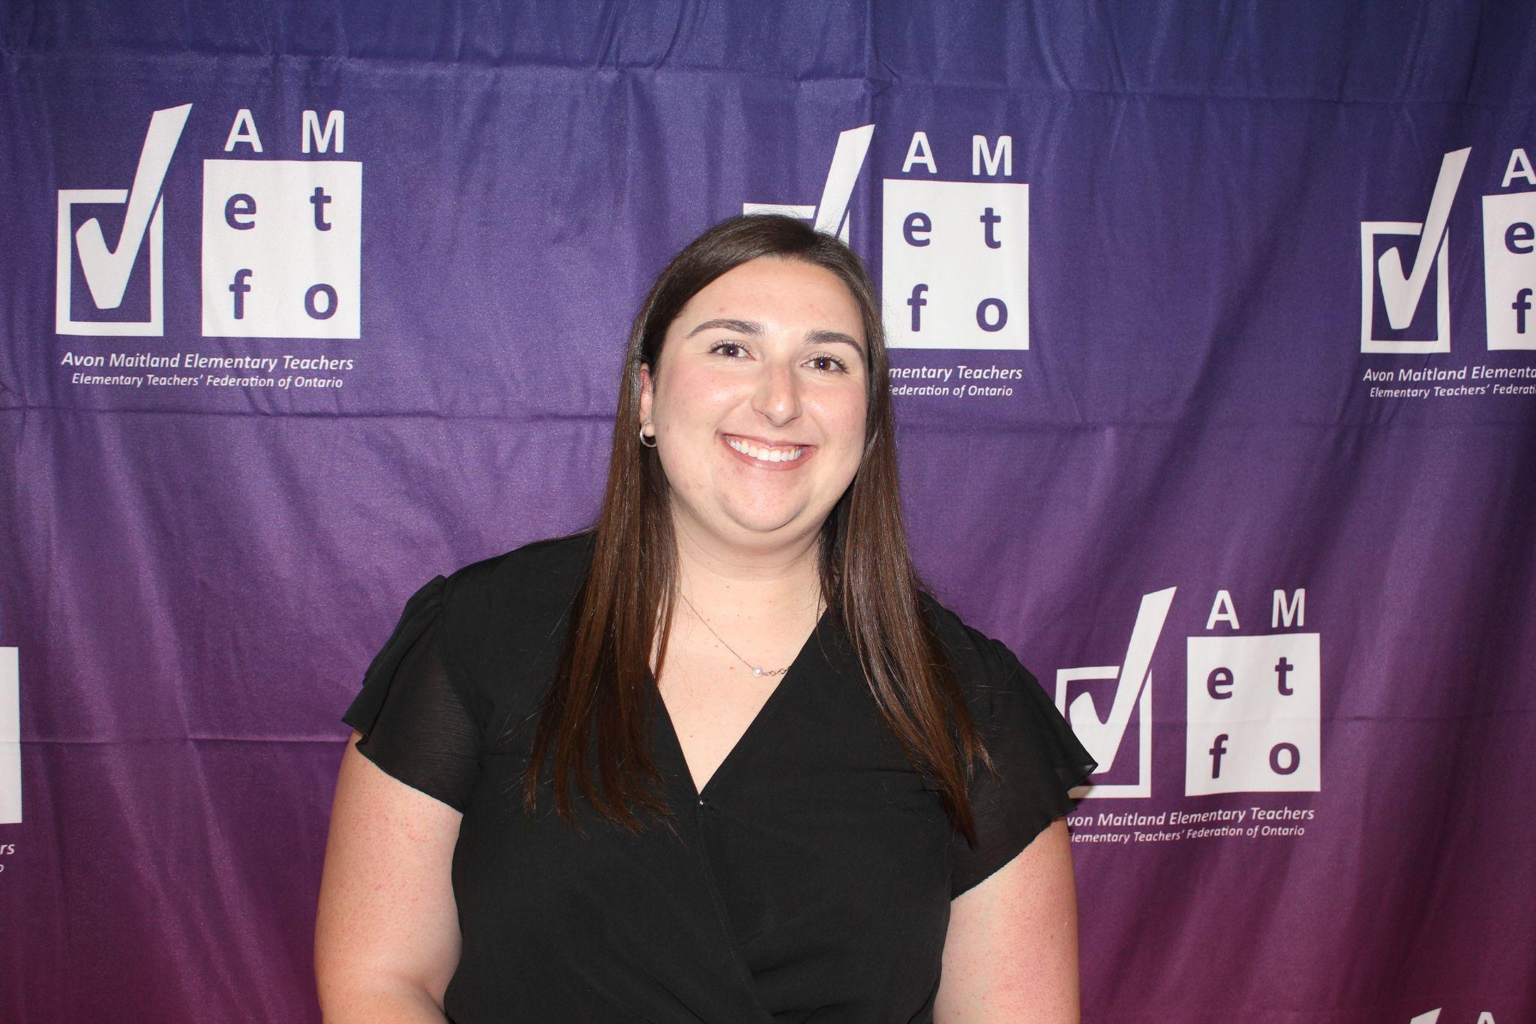
Mentor/Leadership  Mike Glover | Occasional Teacher  MackKenzie Ansems

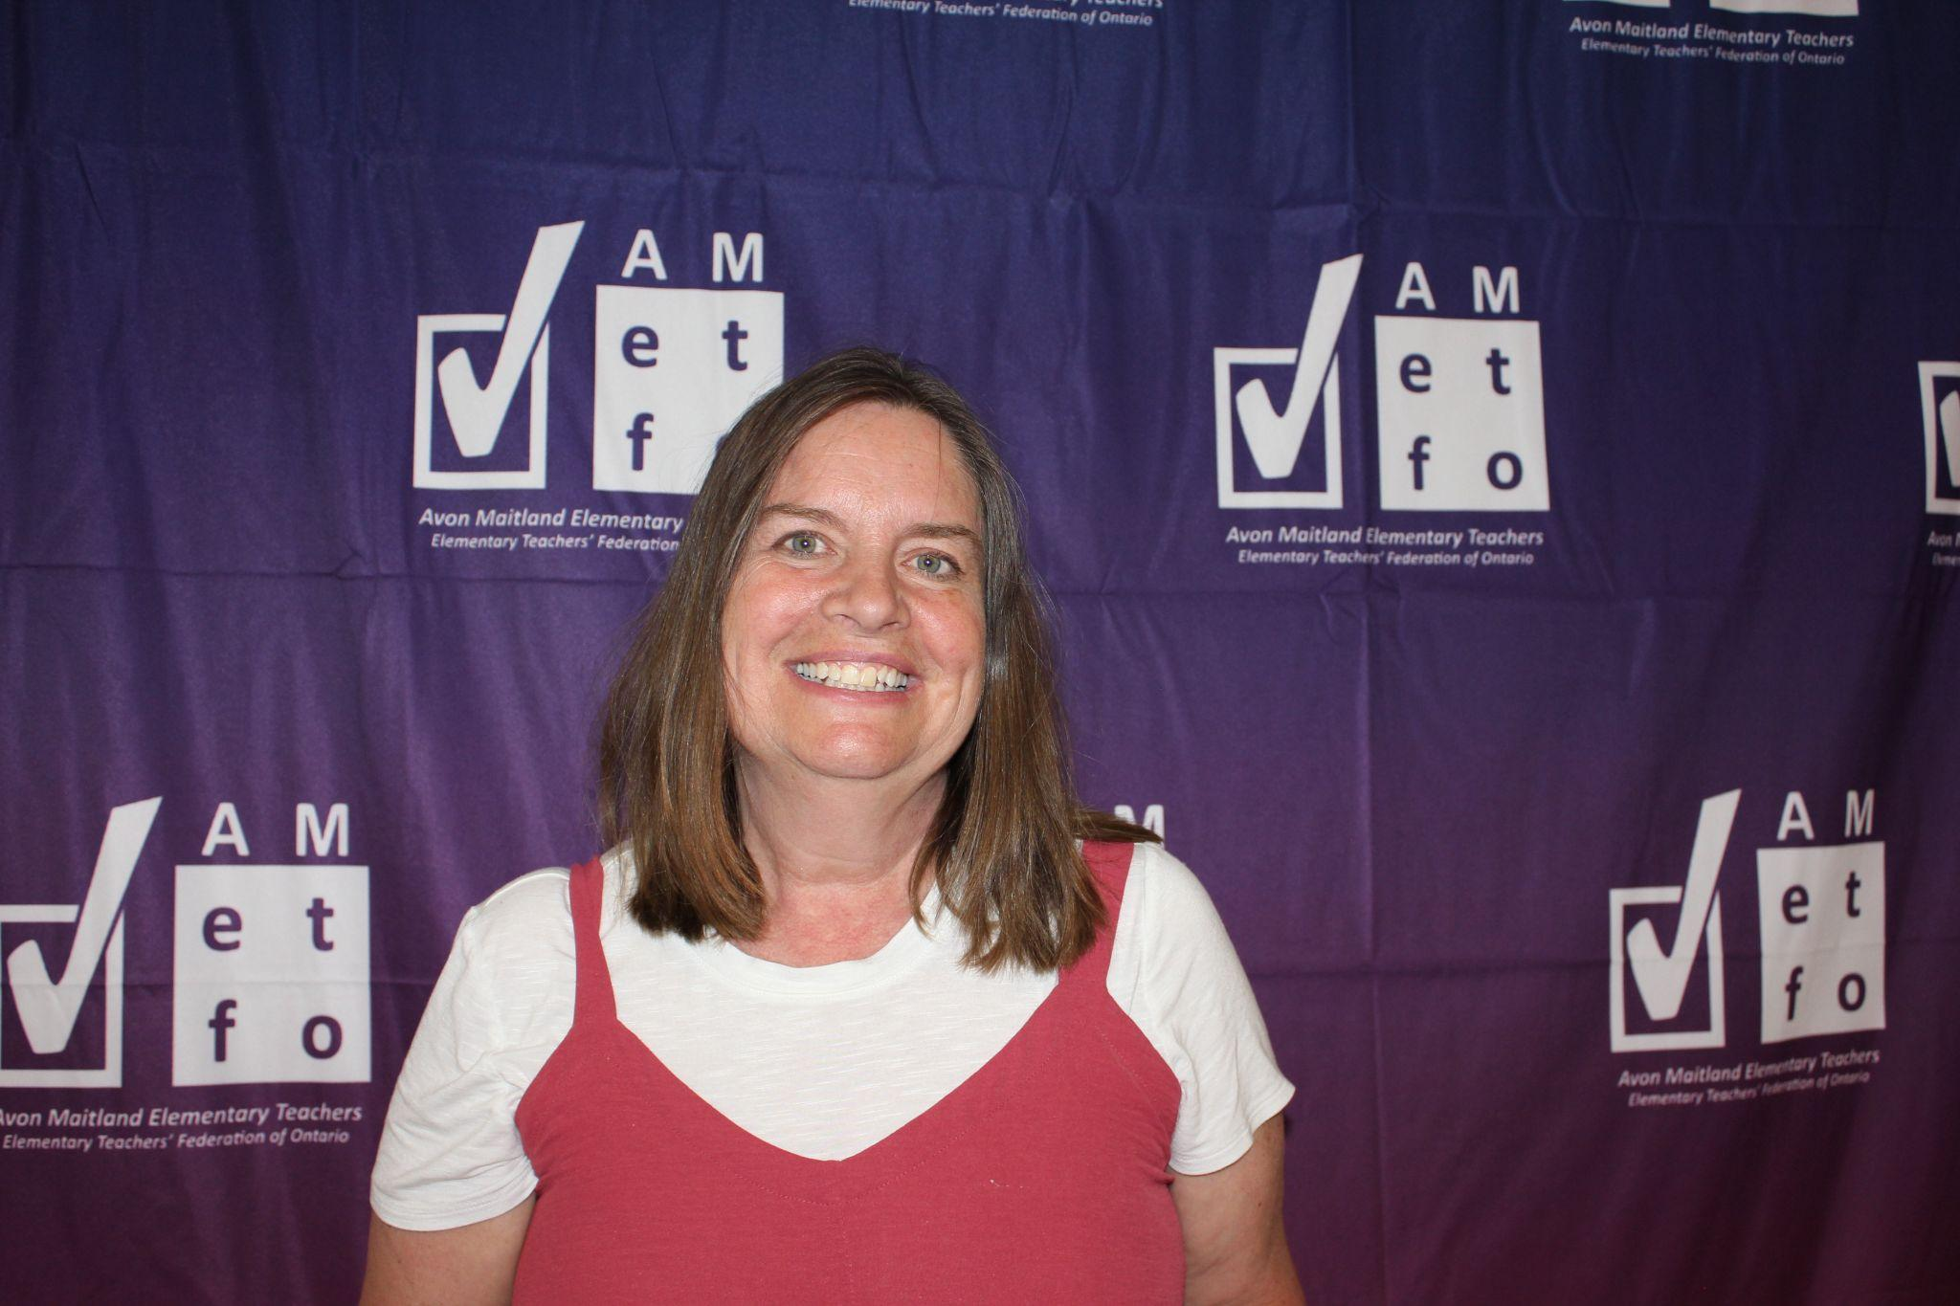 | 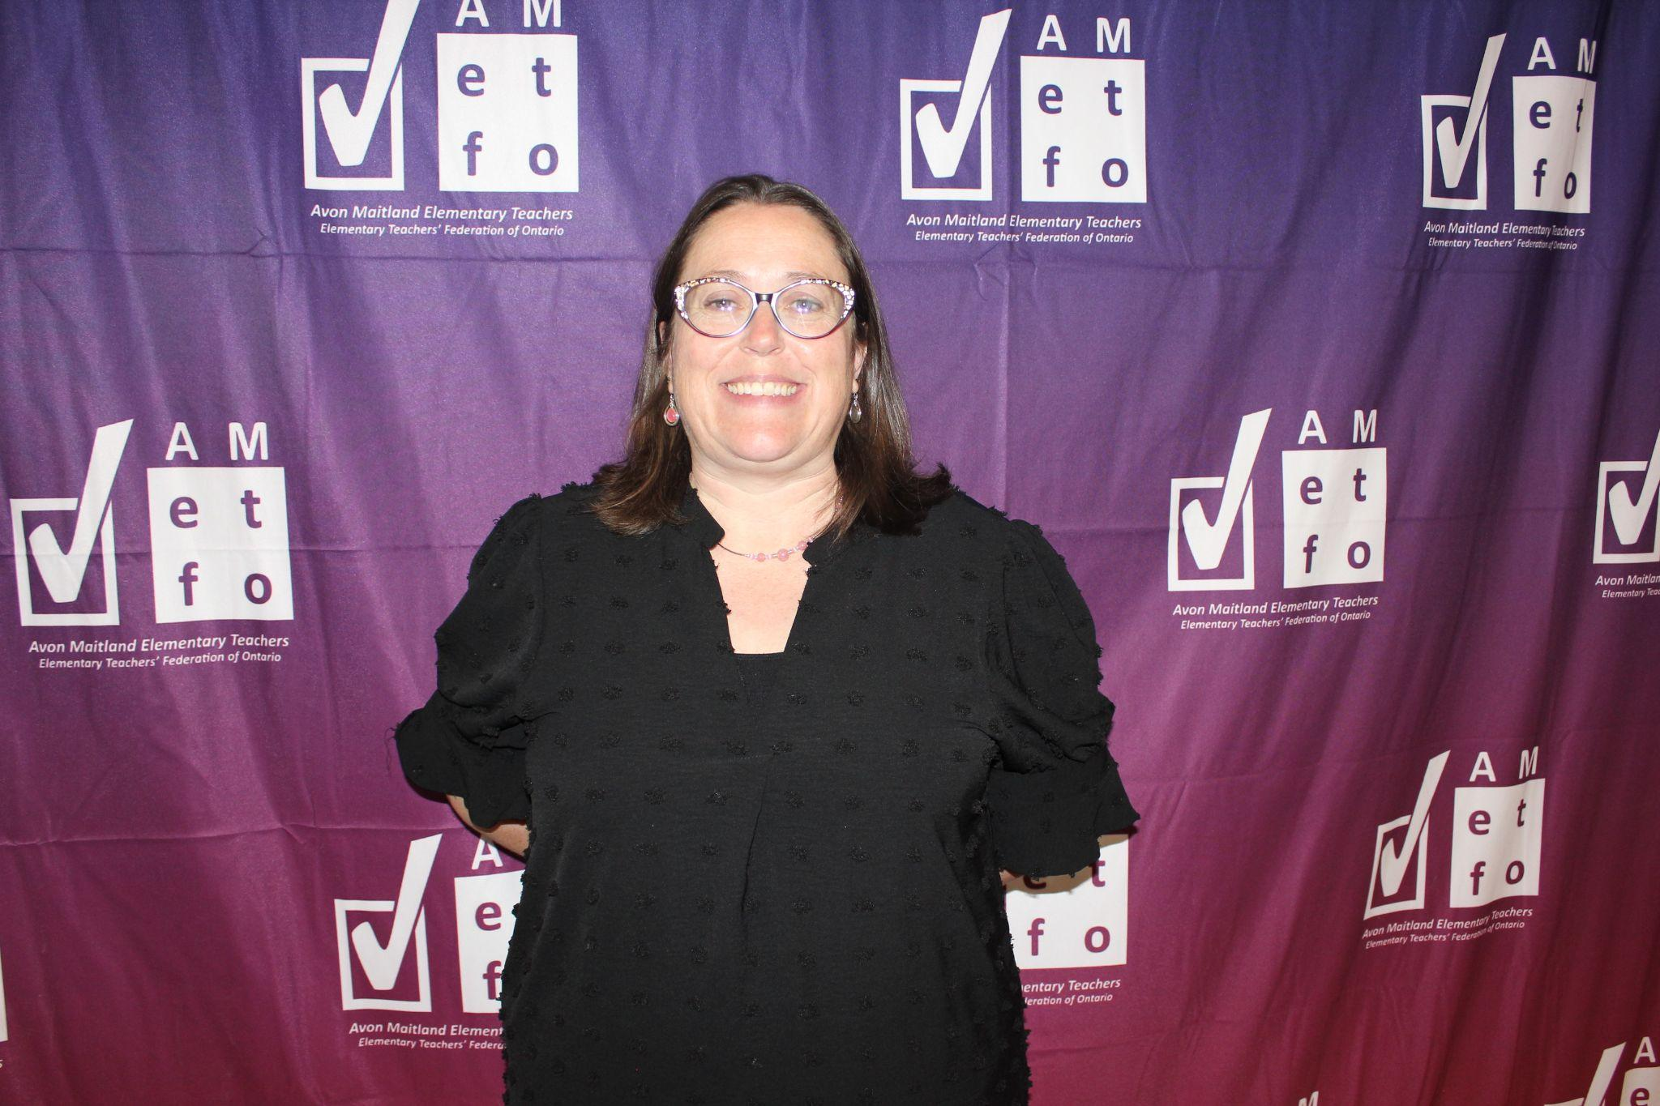
Support Person of the Year  Dana Hyde | Support Person of the Year  Samantha Crawford
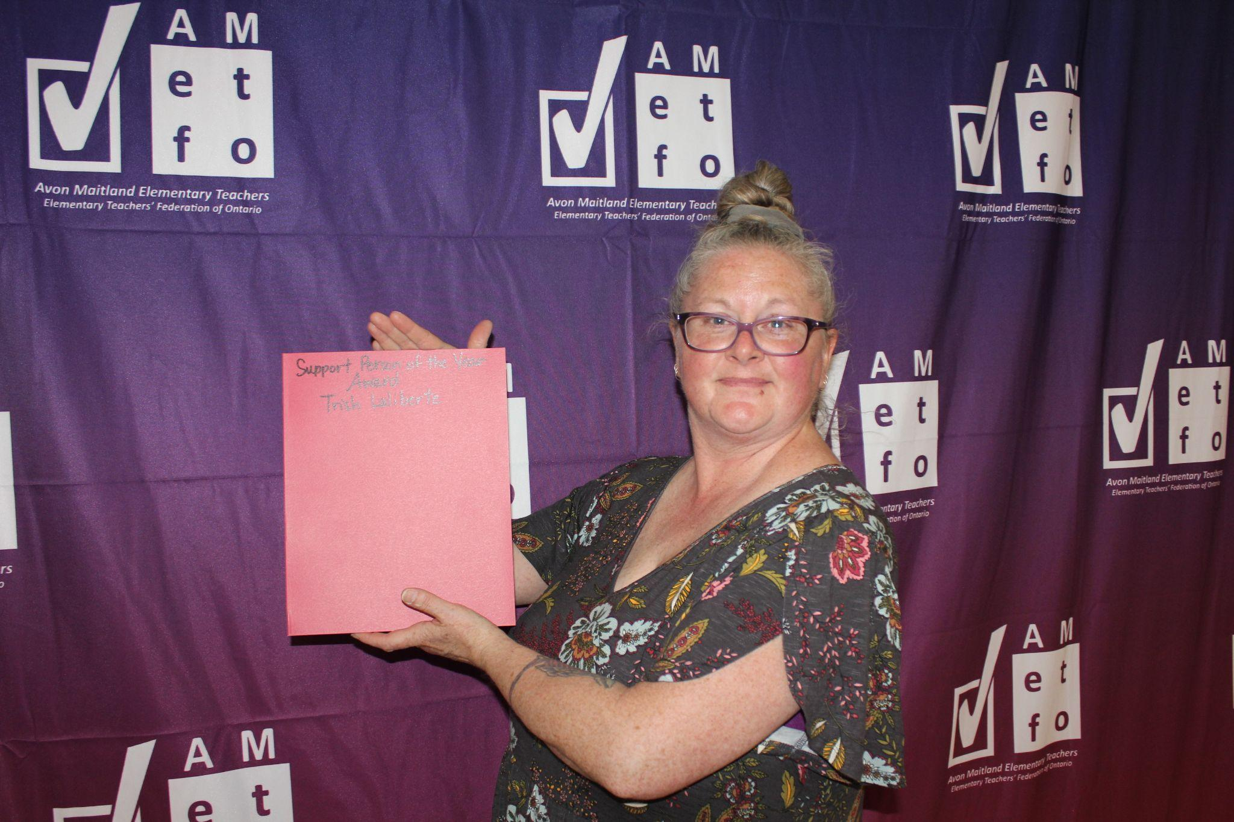 | 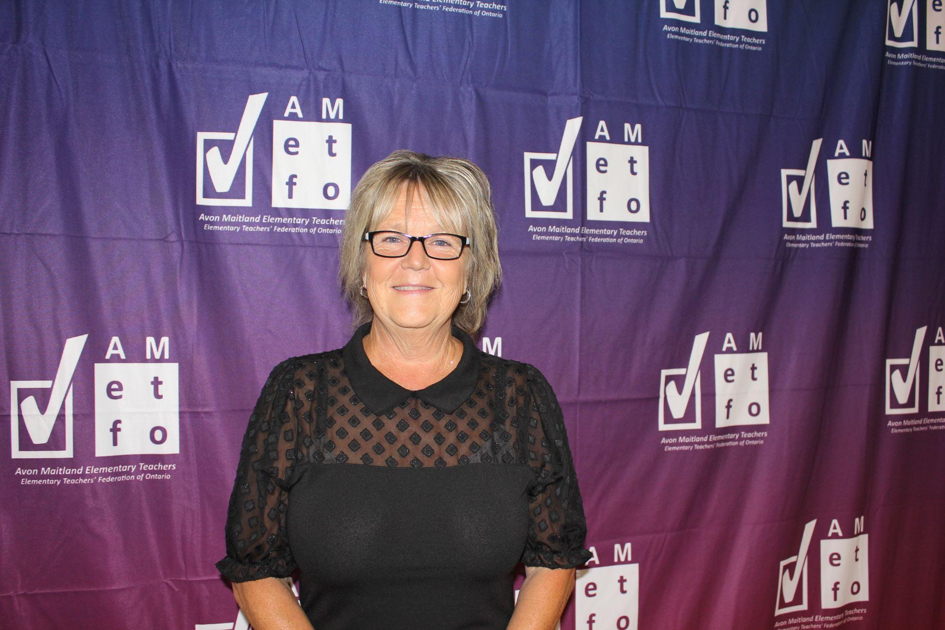
Support Person of the Year  Trish Laliberte | Support Person of the Year  Lori Kuttschrutter

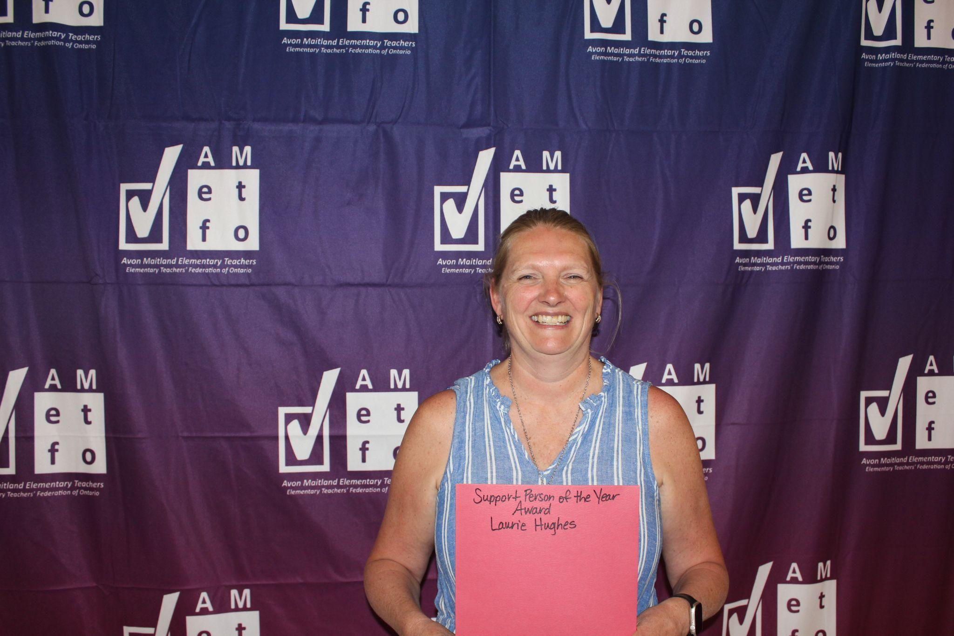 | 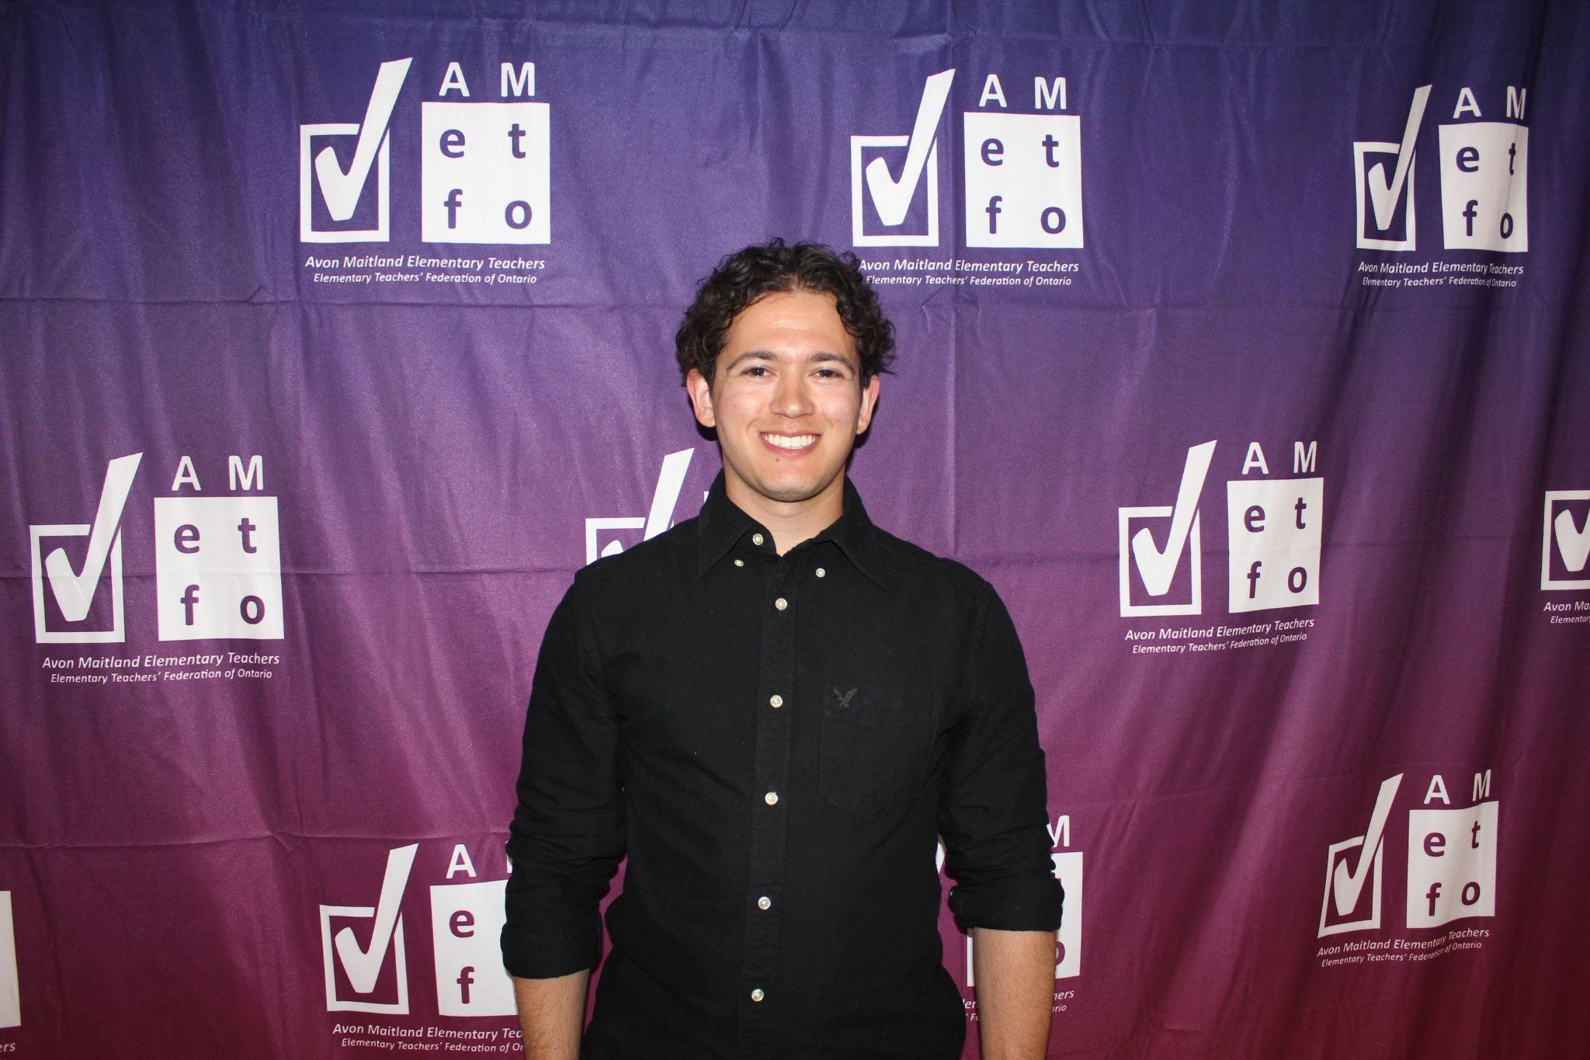
Support Person of the Year  Laurie Hughes | Support Person of the Year  David Indovina
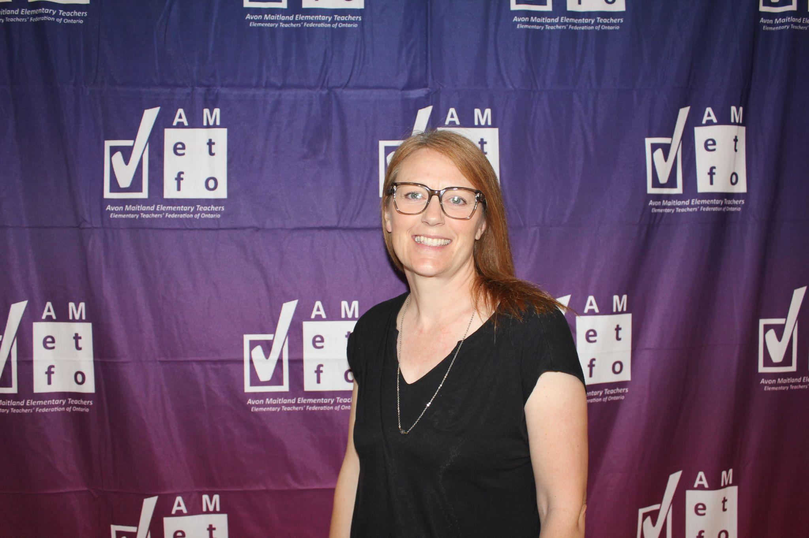 | 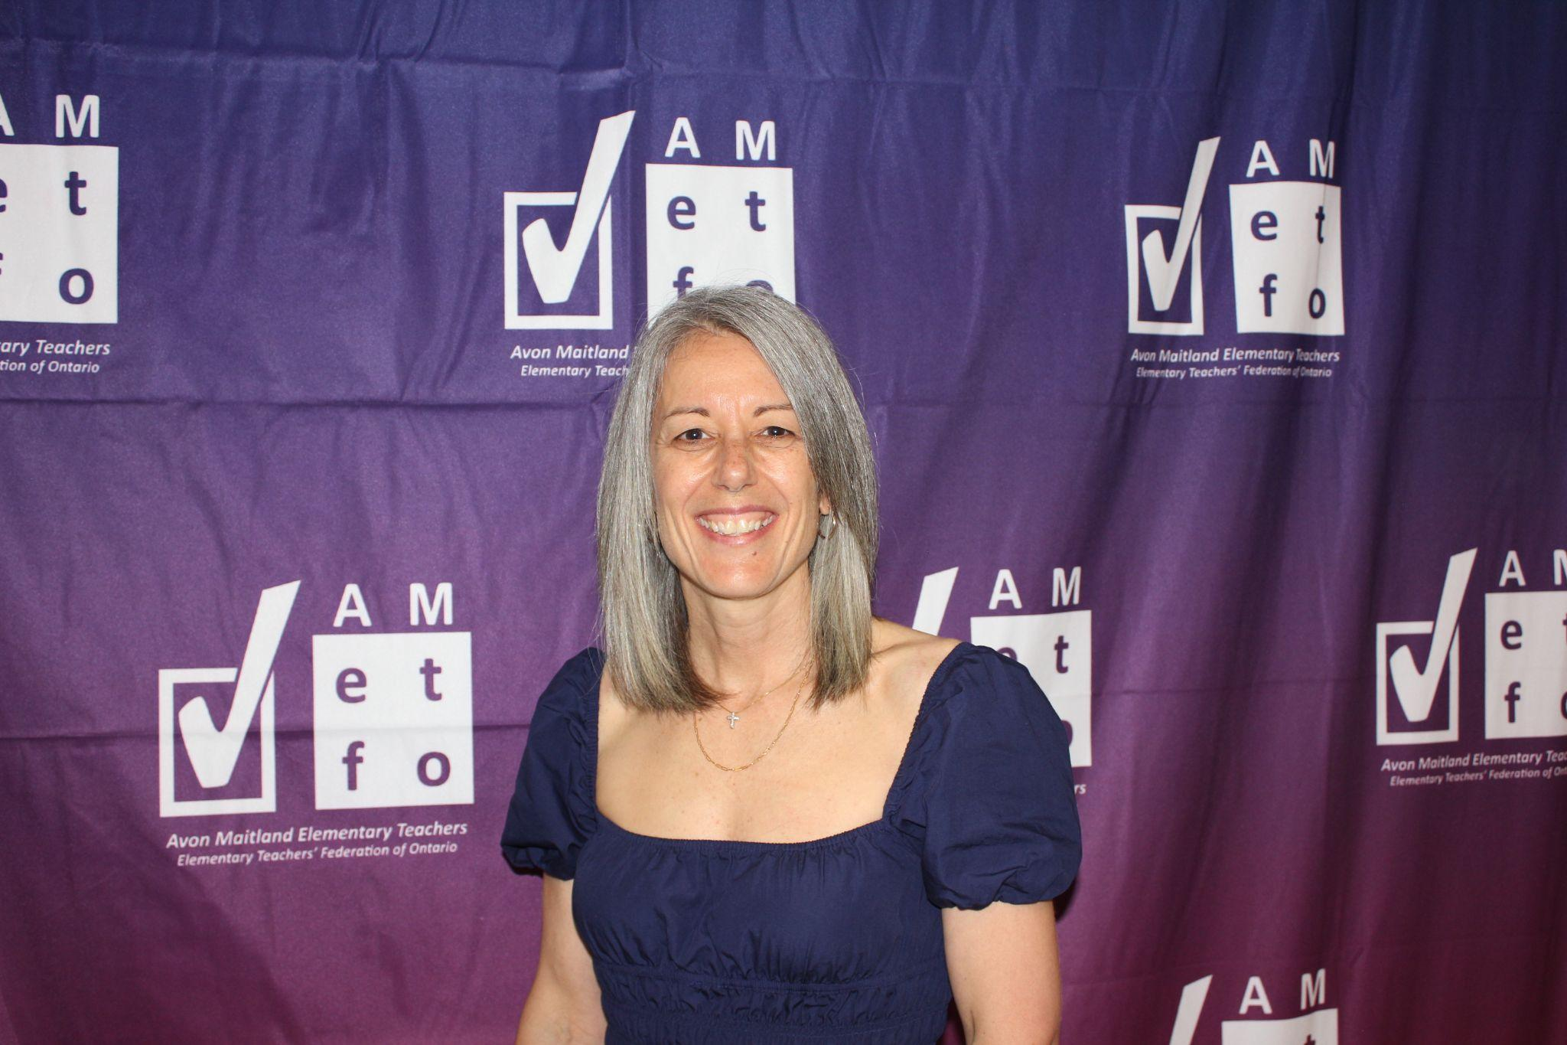
Tod Riddell Special Education  Celeste Mitchell | Tod Riddell Special Education  Sara Steckley-Gerber

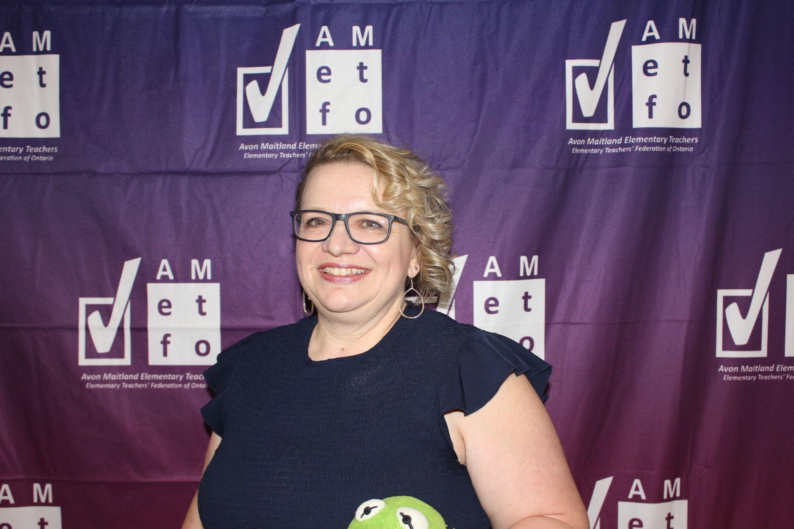 | 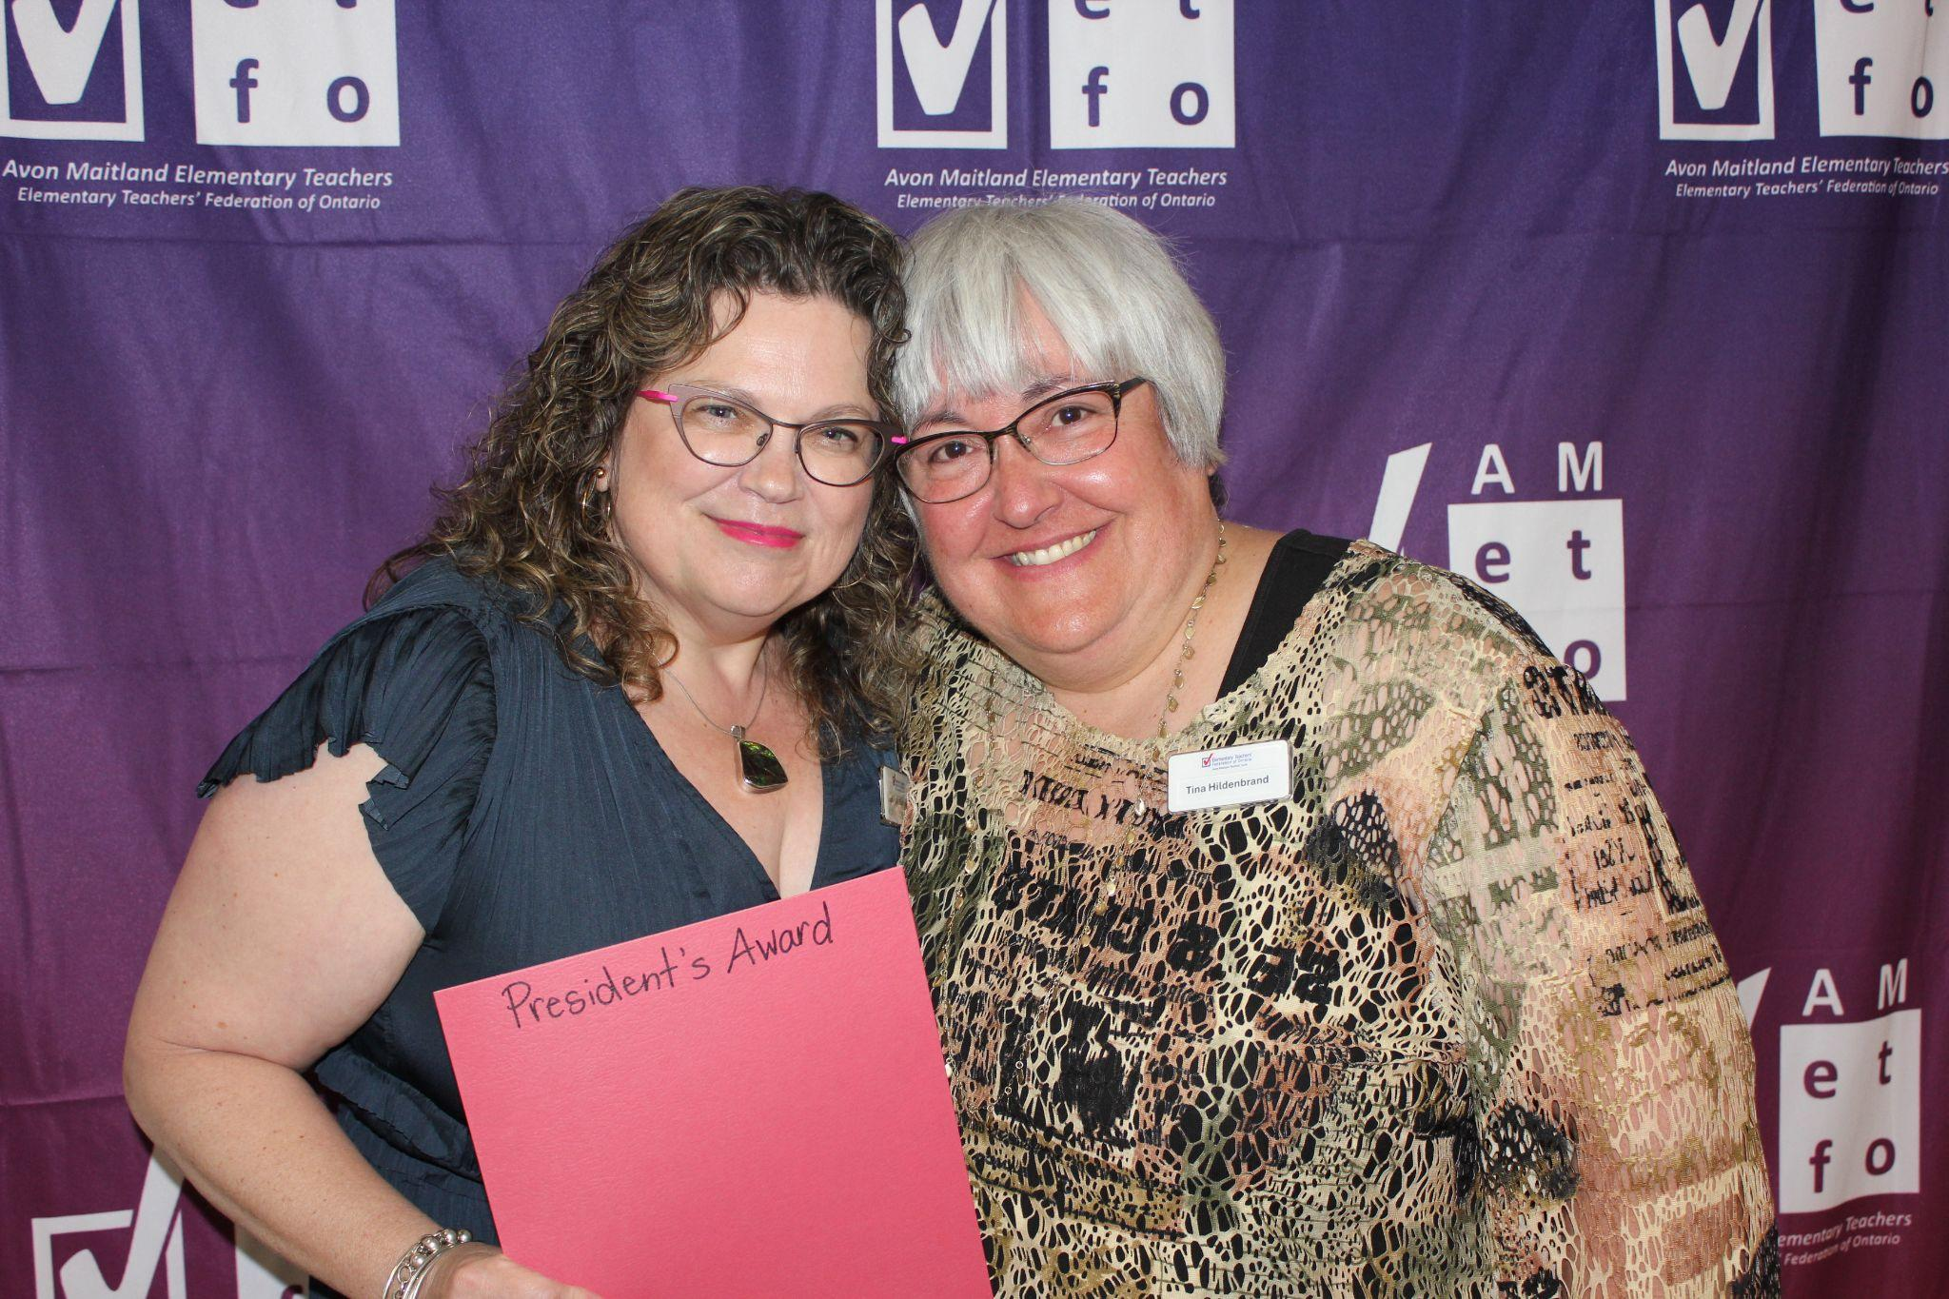
Bed Bushfield French Education  Janice Kane | President’s Award  Tina Hildenbrand (right)

AMETFO Retirees 2026

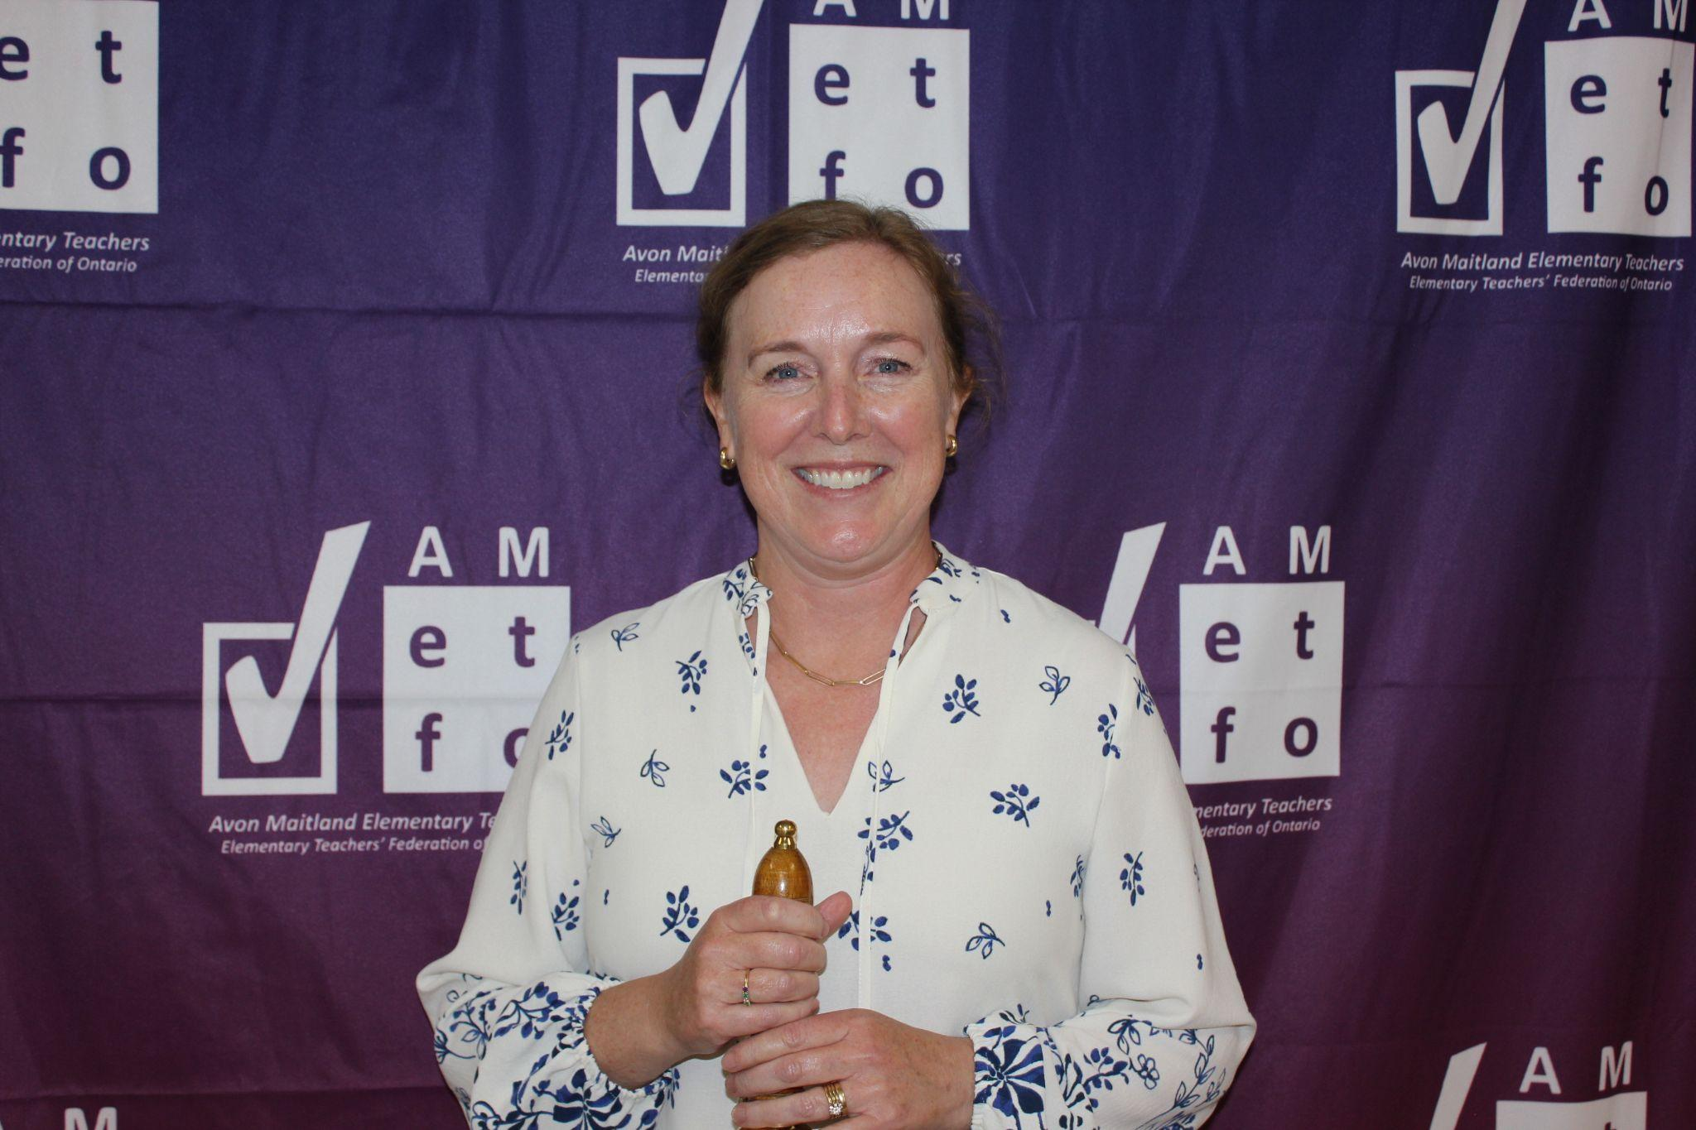  Carolyn Mathieson | 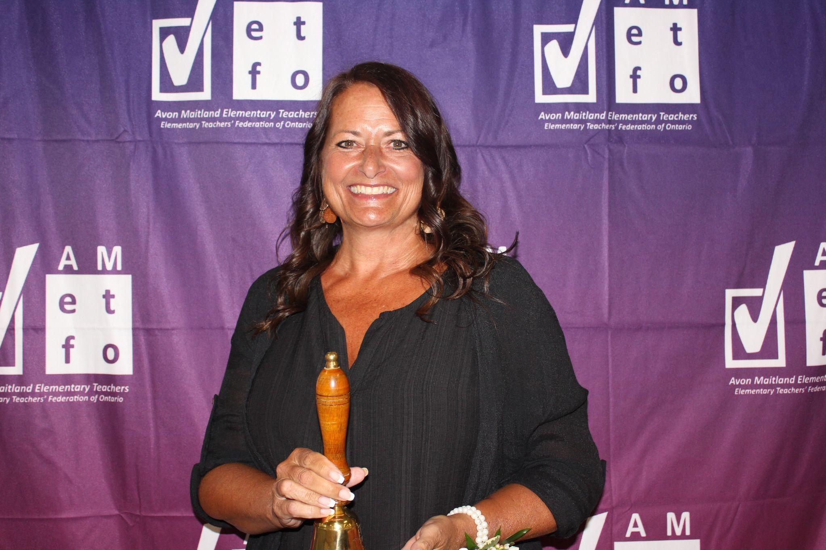  Debee Stern | 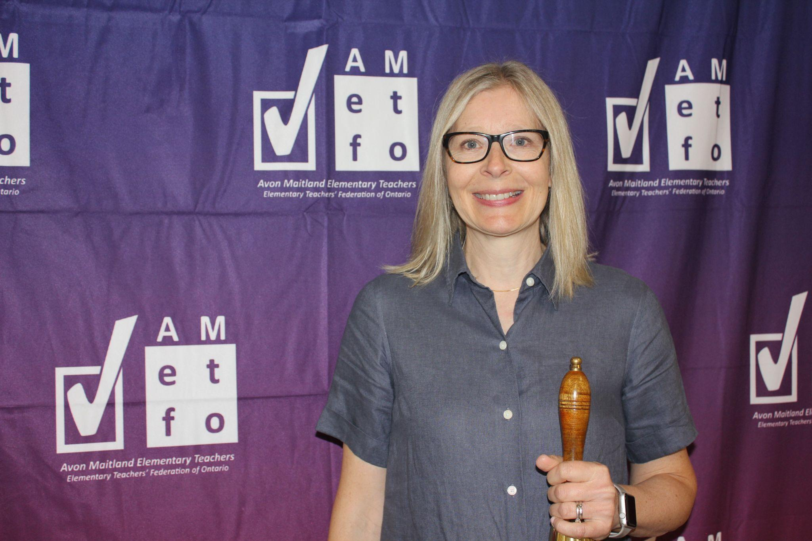  Arlene Hoonaard

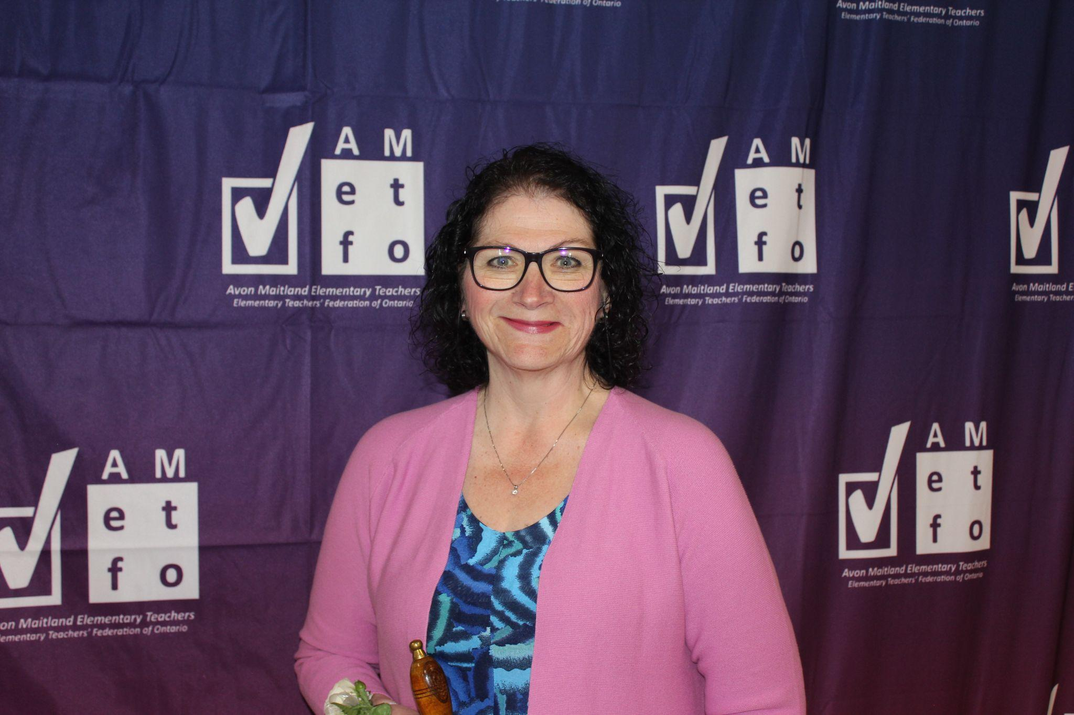  Sheila Arnold | 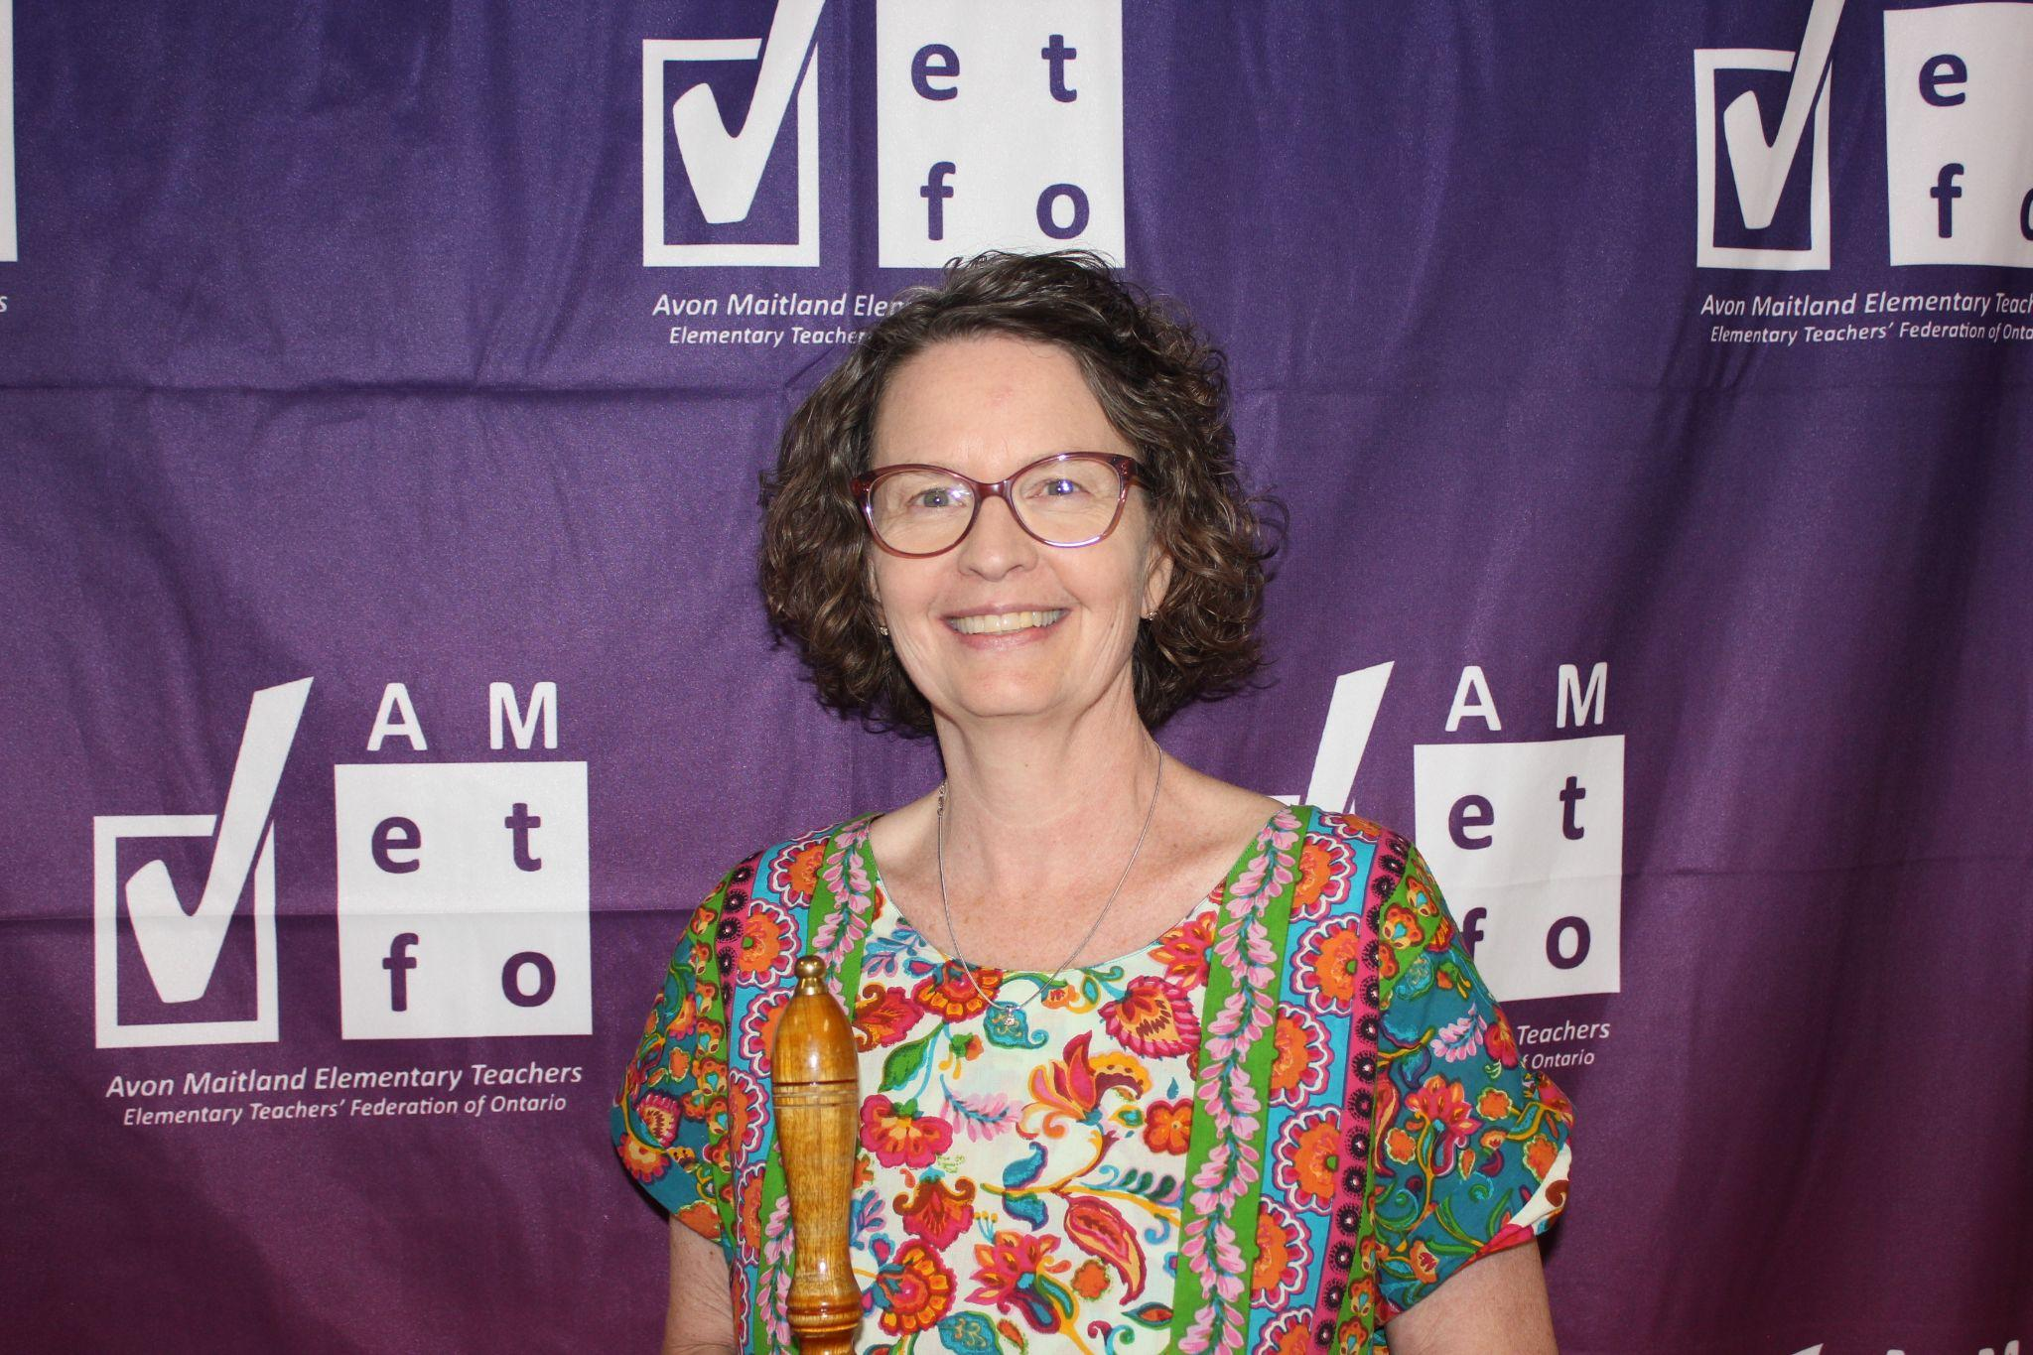  Monique Cameron | 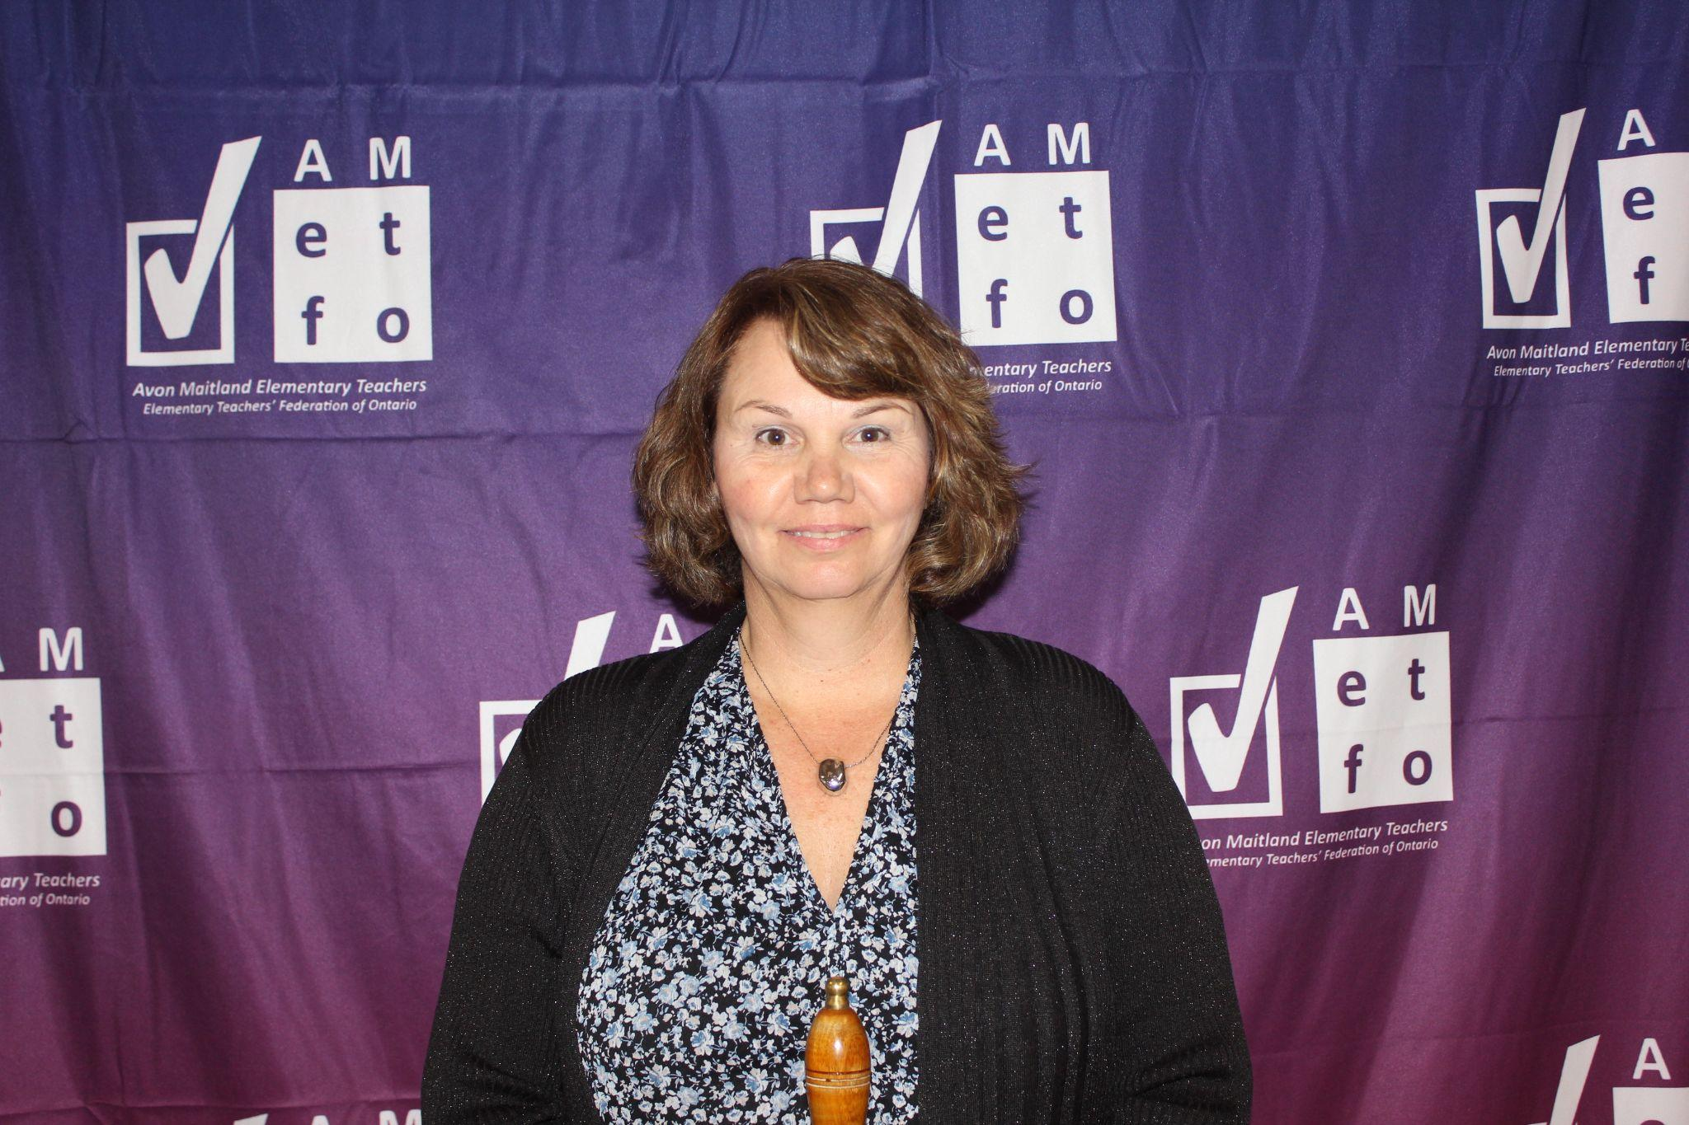  Lori Bearss

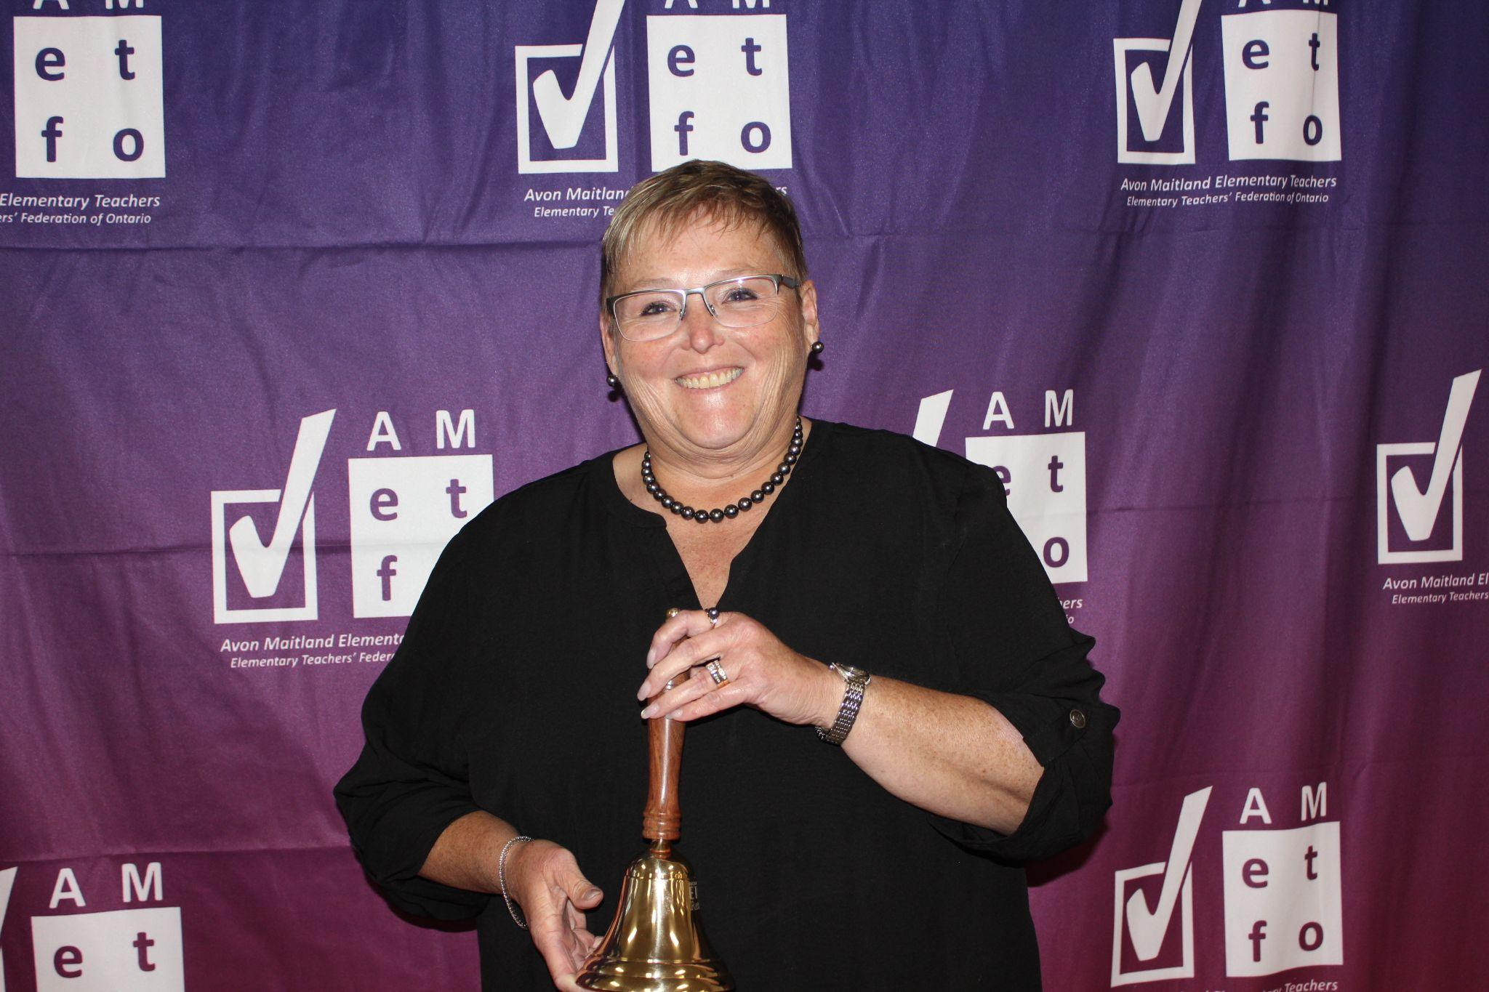  Karen McLellan | 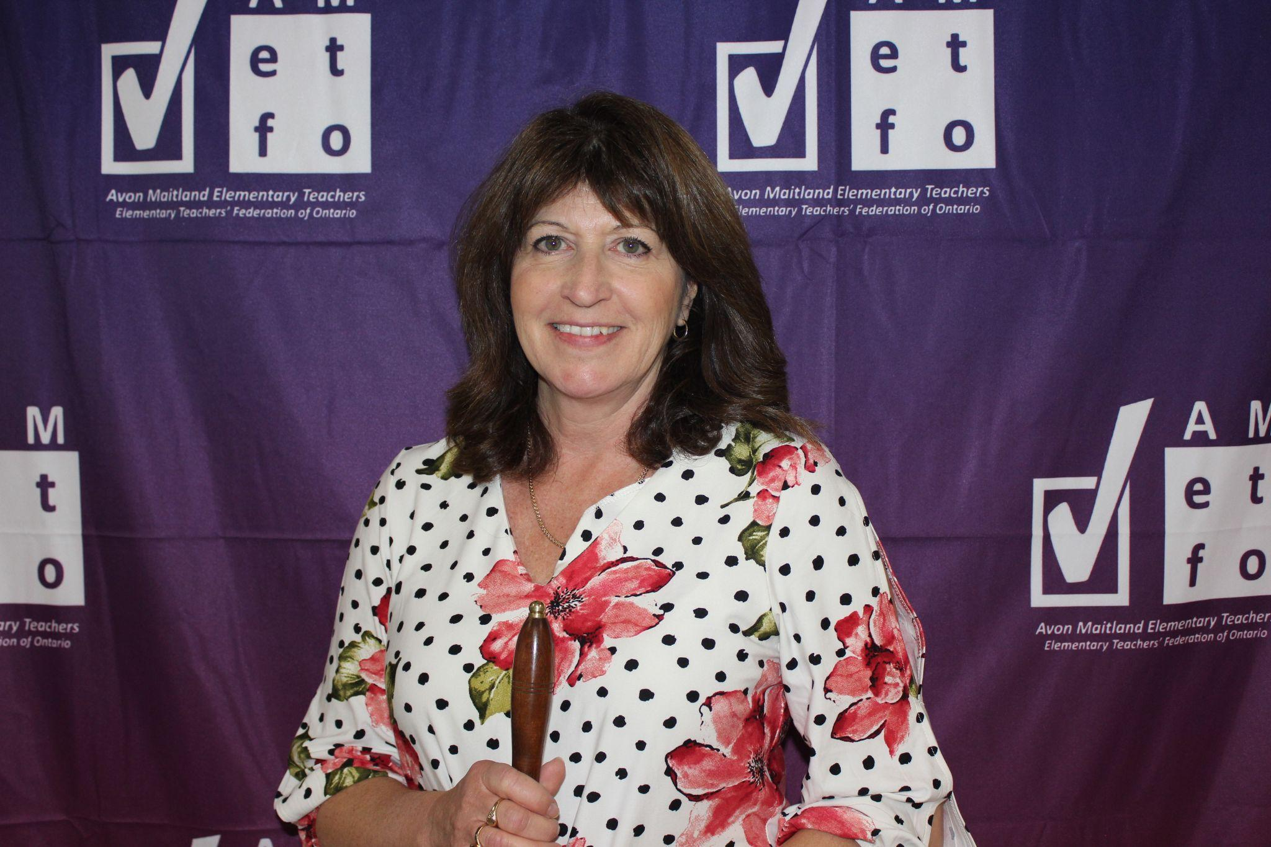  Sharon Reay | 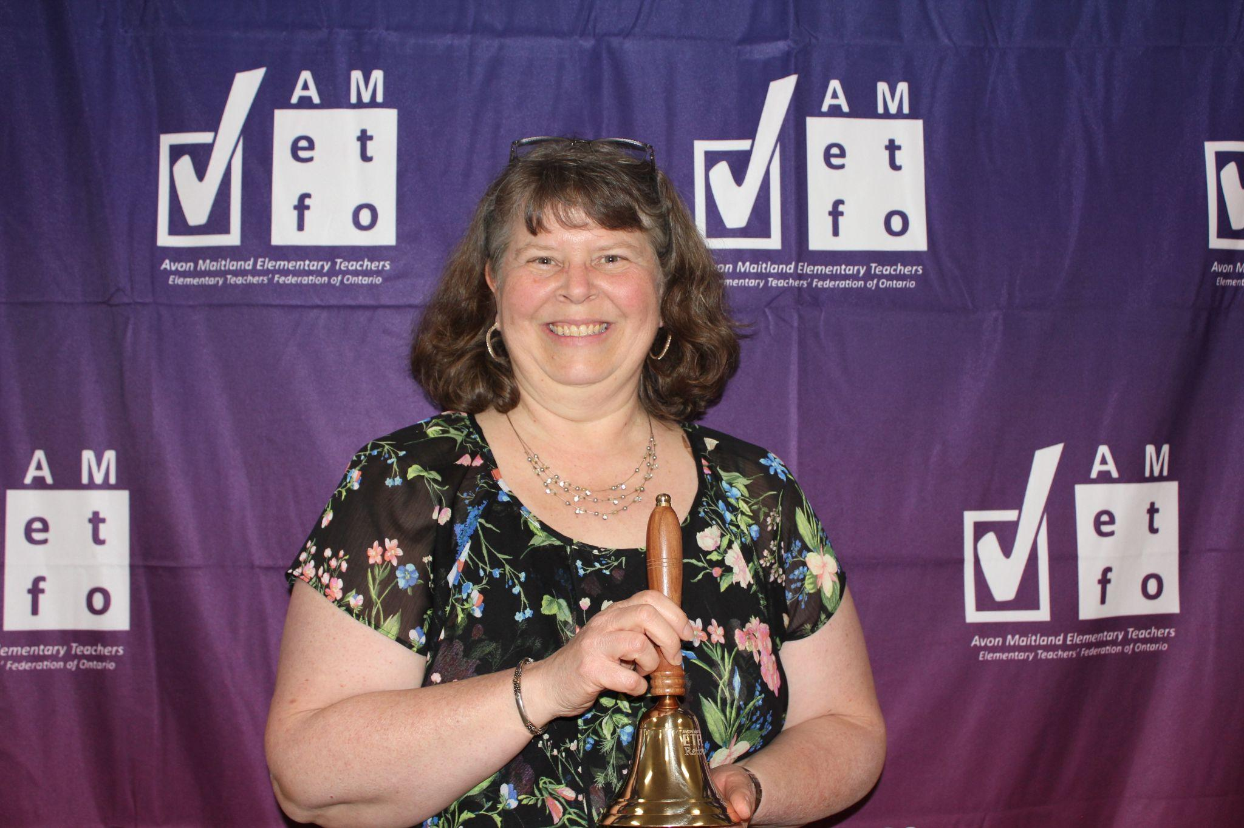  Deb Bice

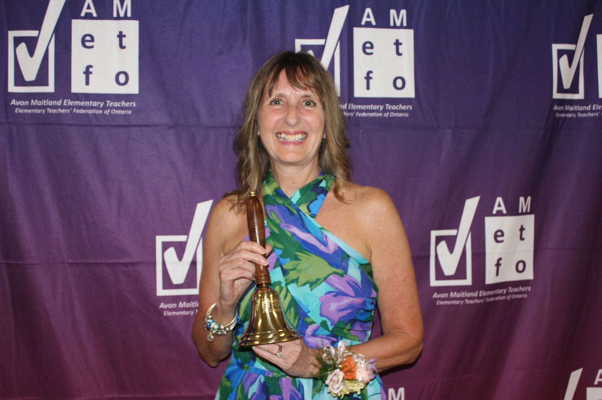  Jeanette Hill | 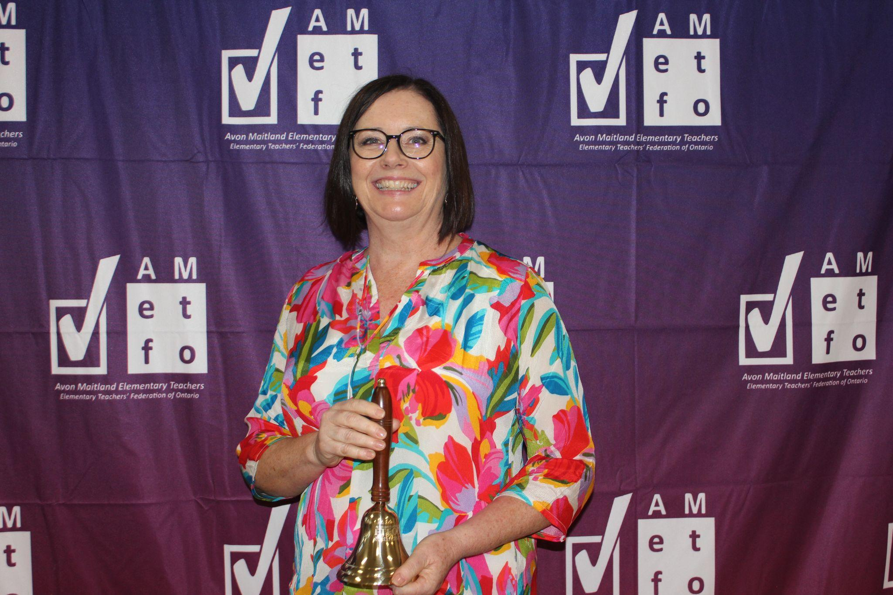  Denise Tedesco | 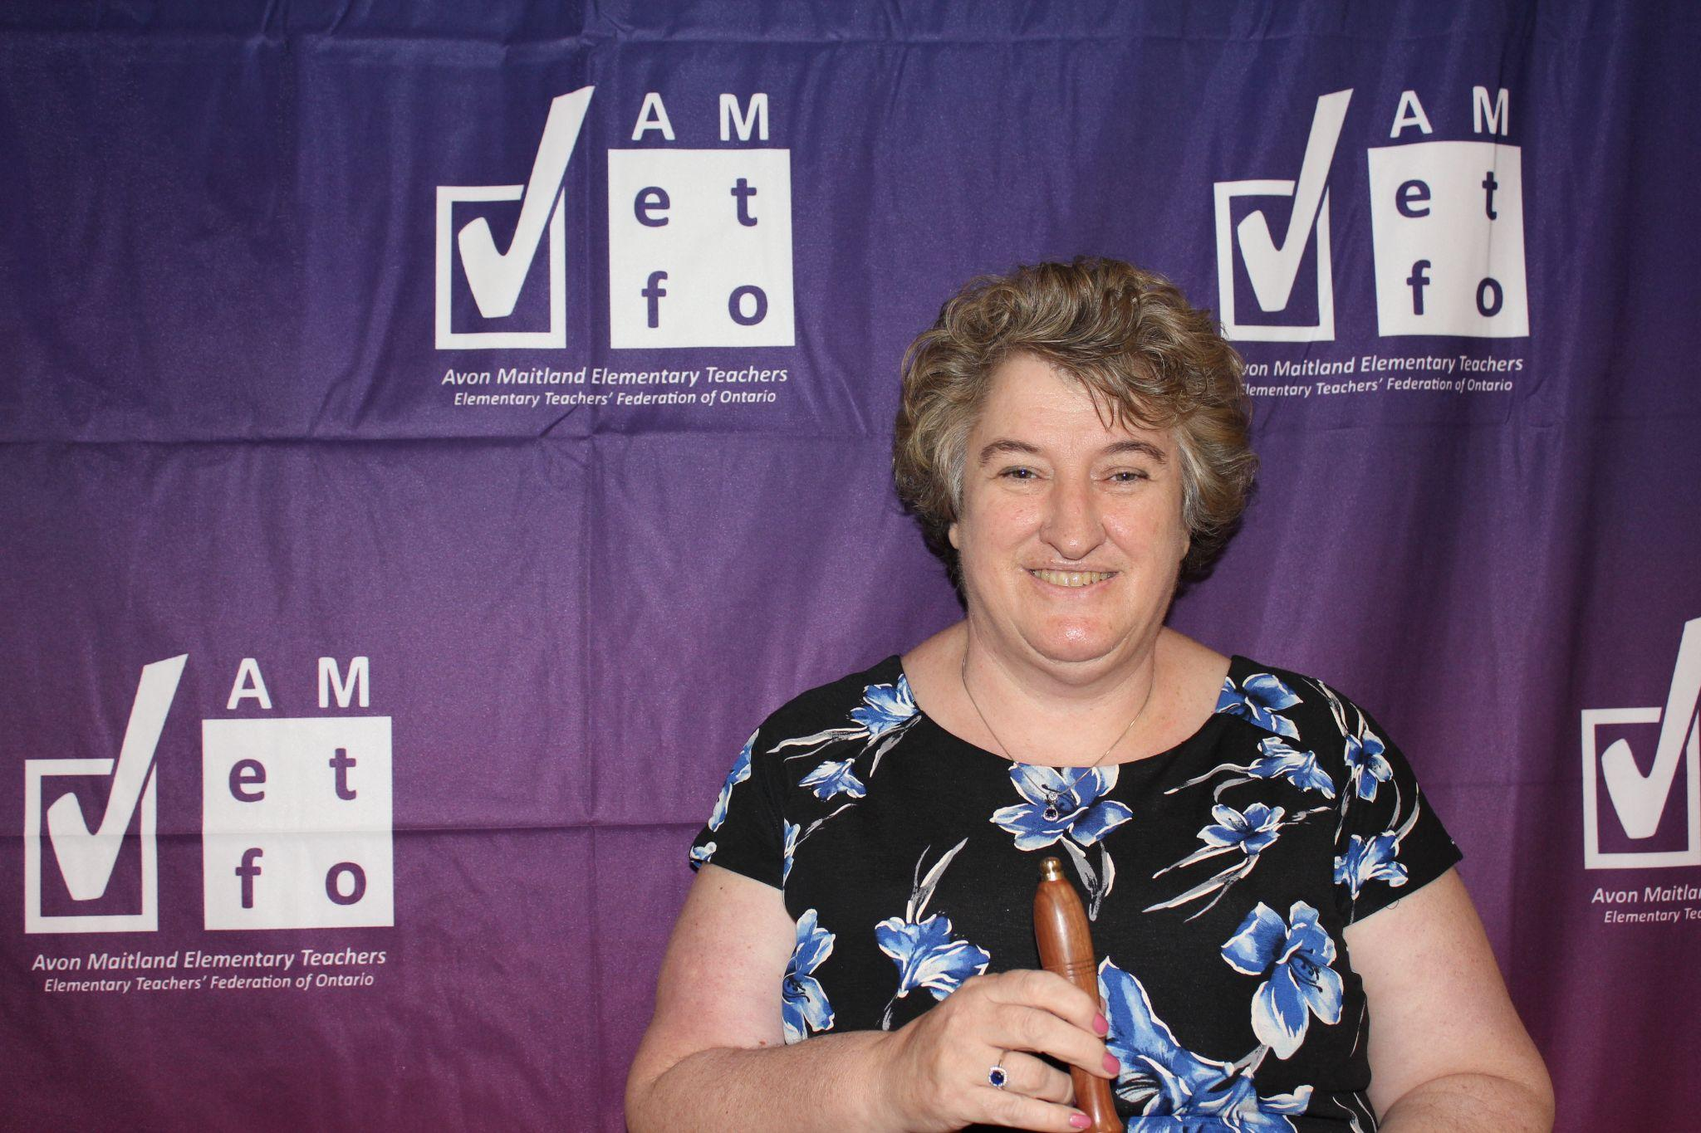  Sheila Schuller

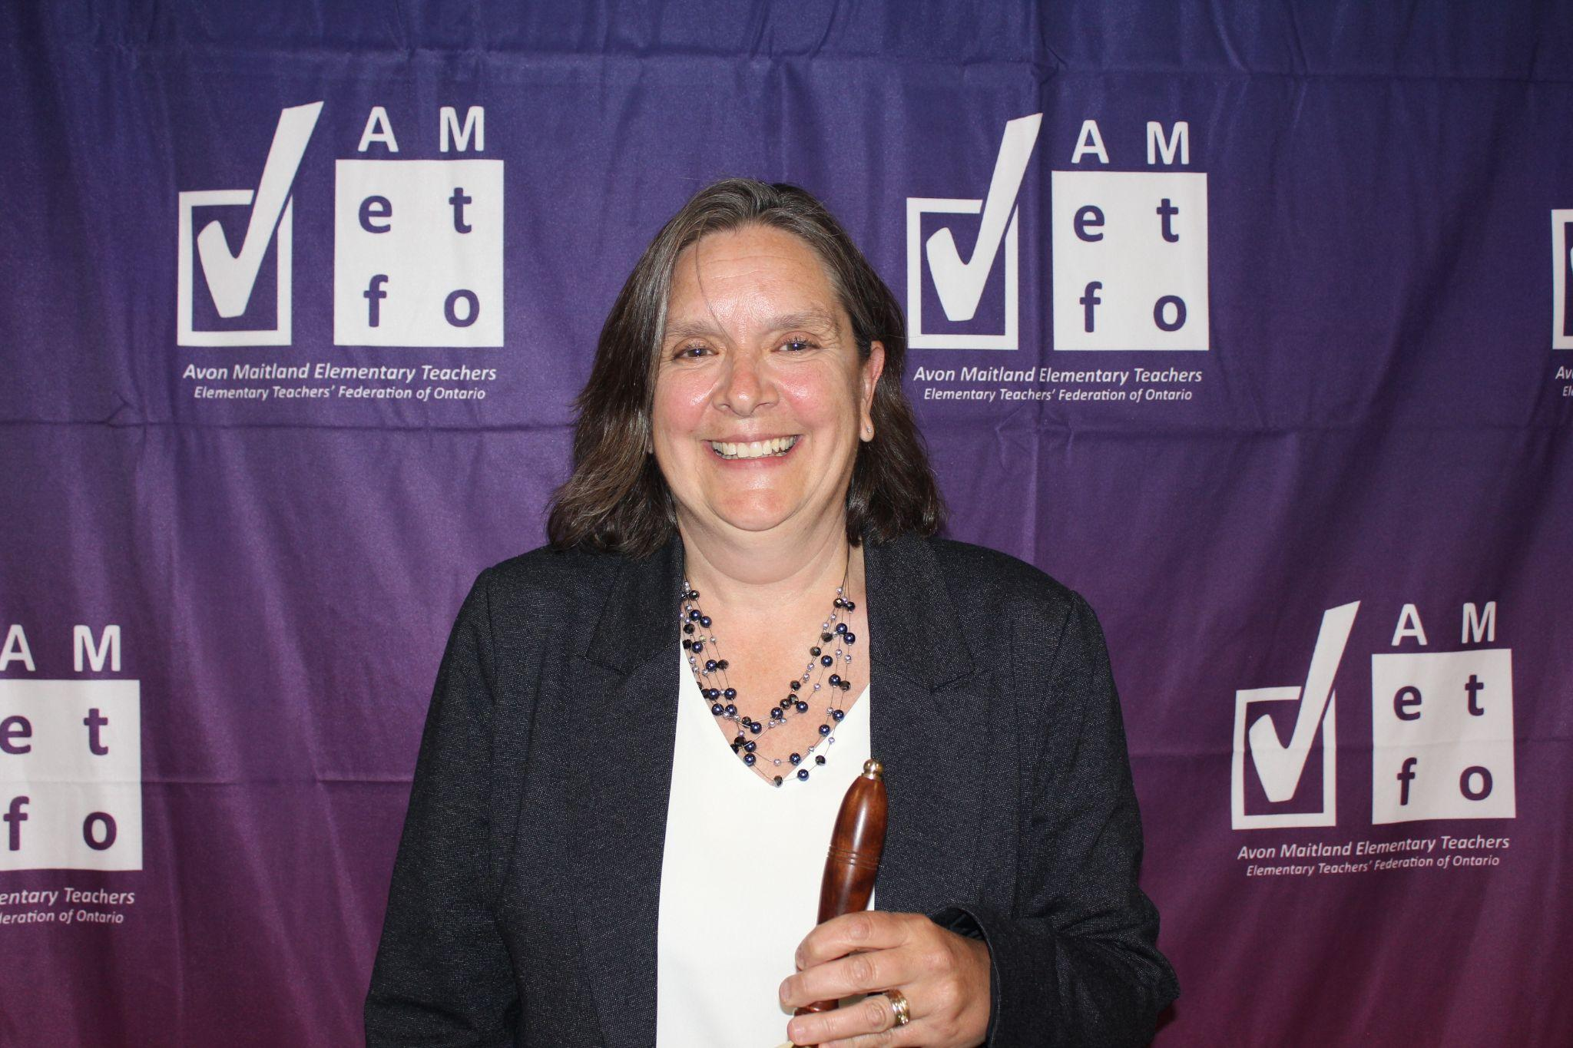  Jennifer Yantzi | 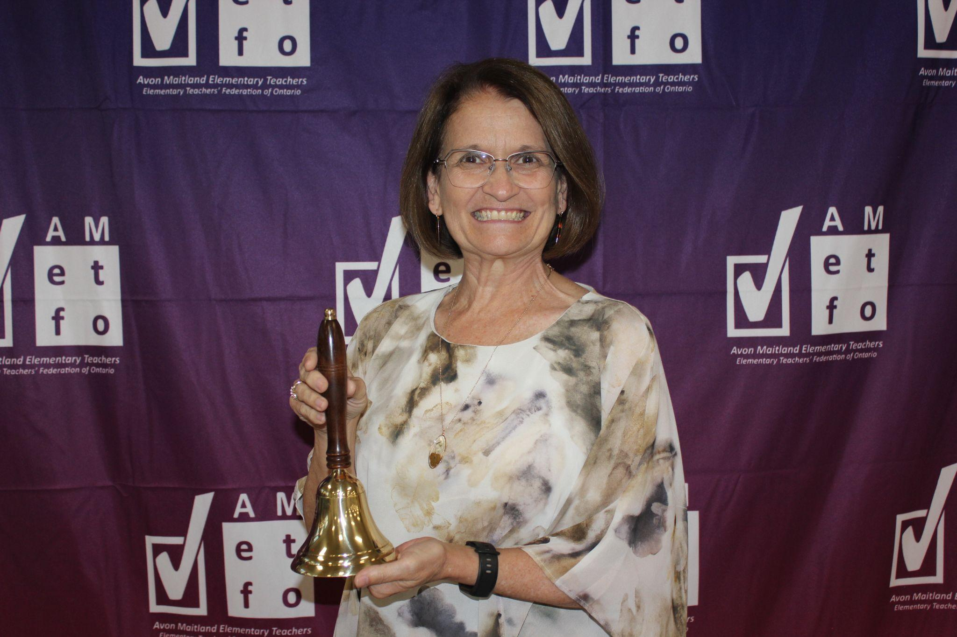  Cheryl Zehr | 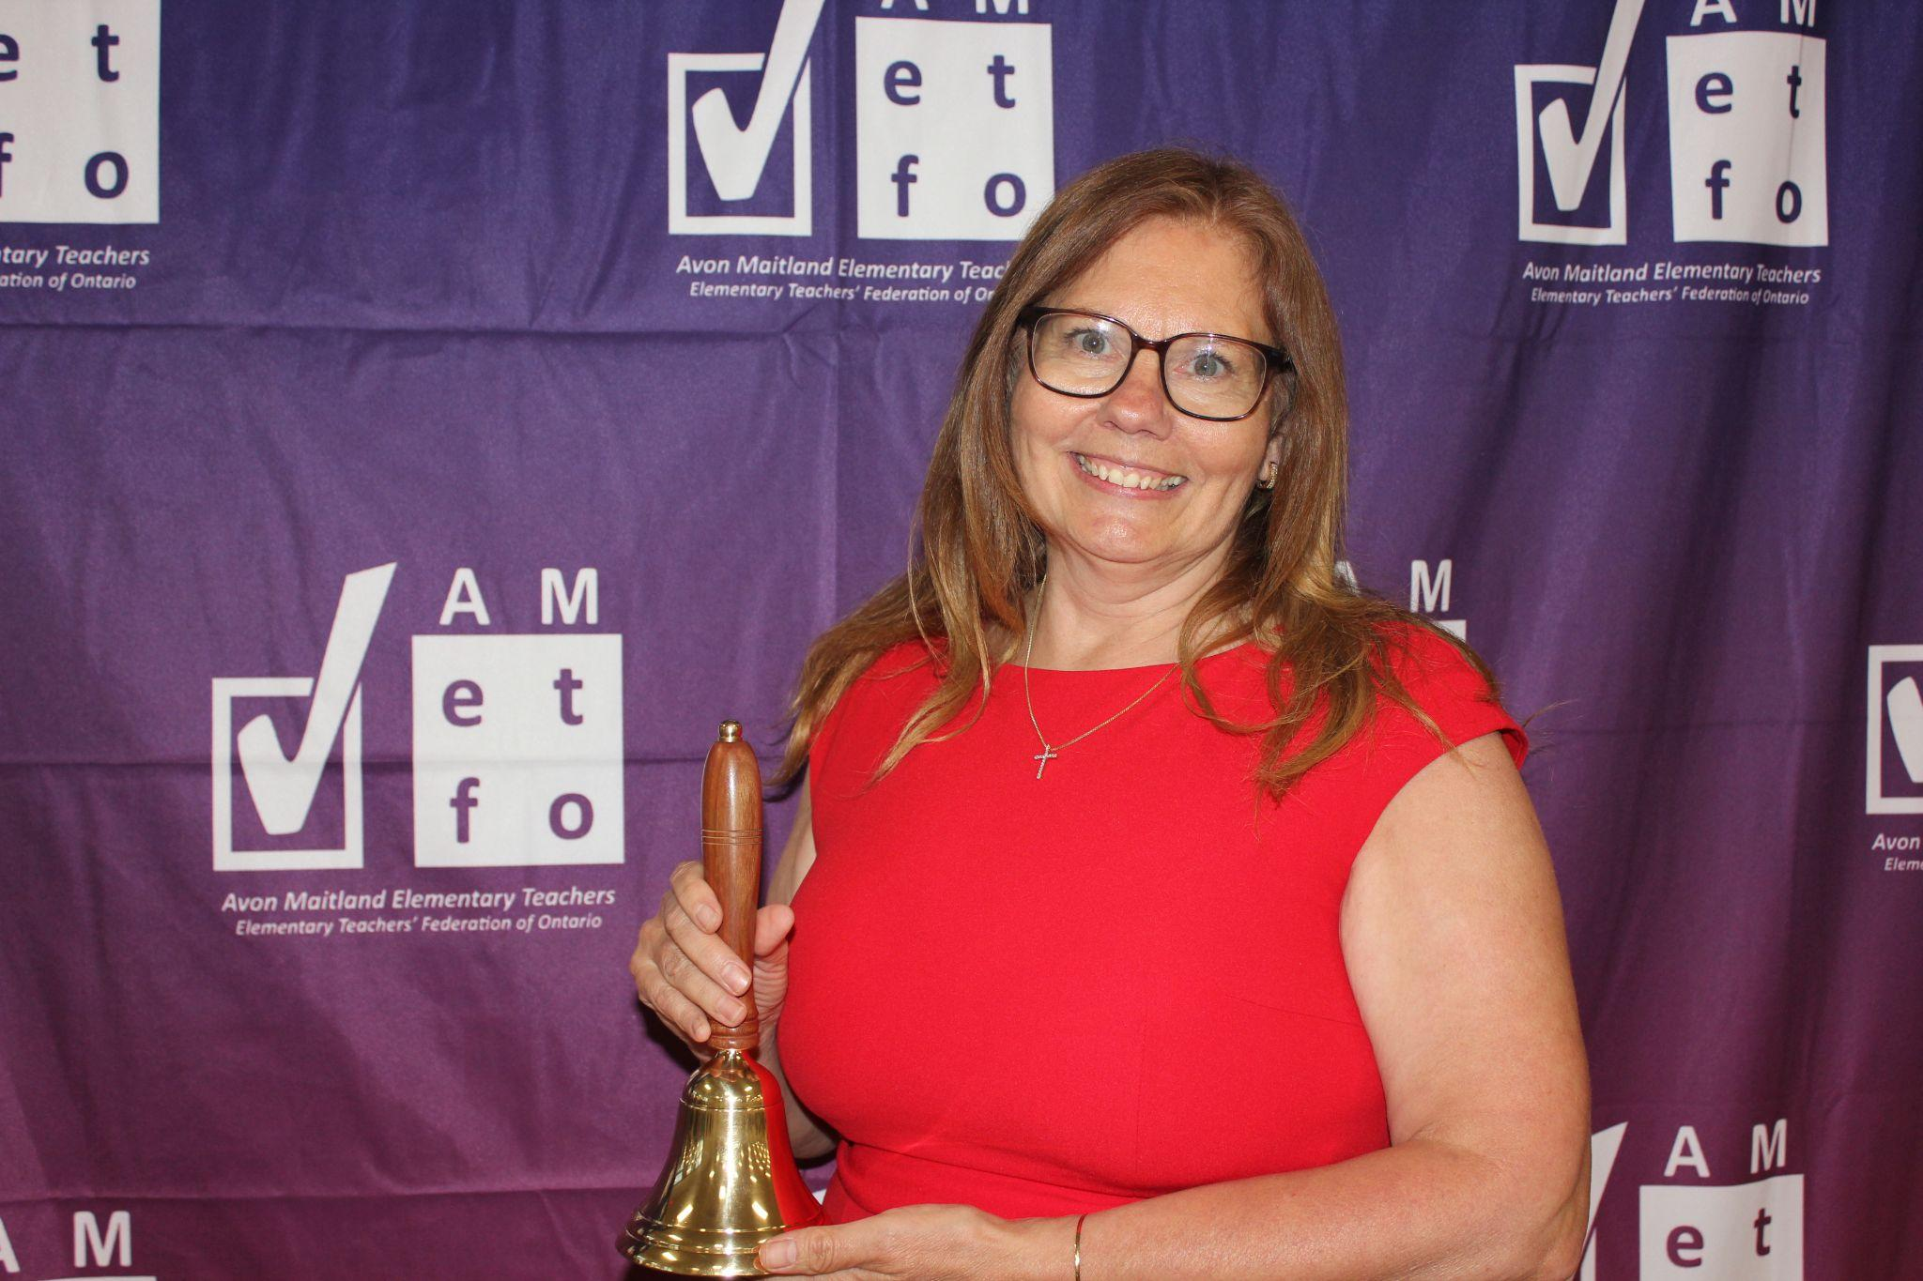  Colleen Priestrap

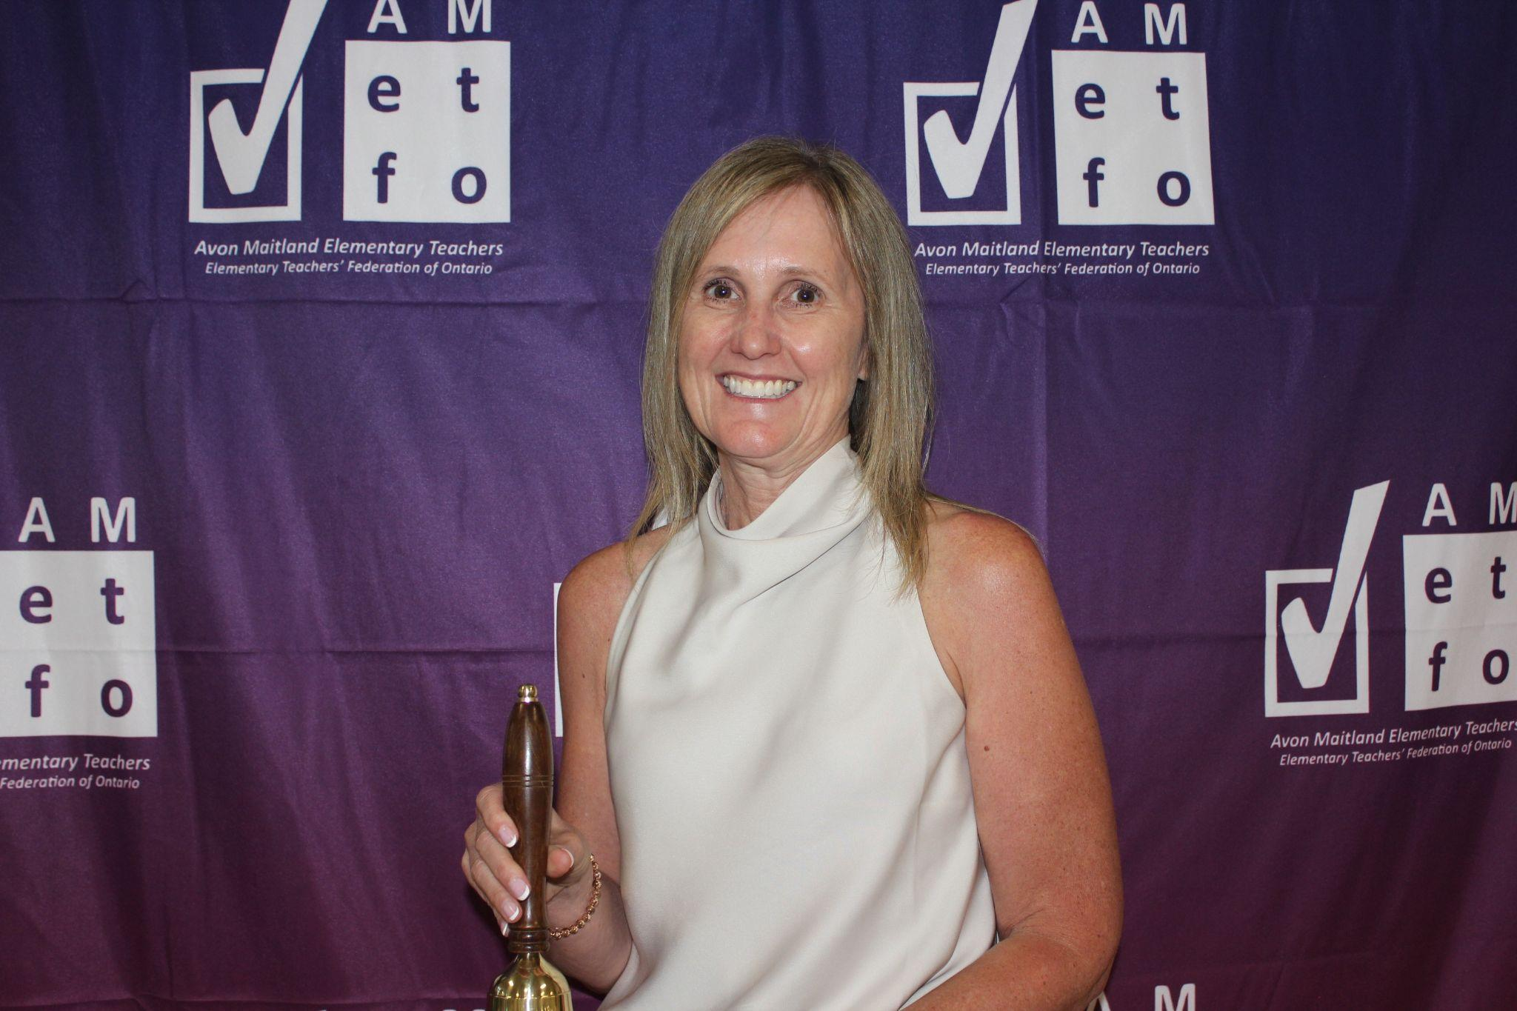  Cheryl Harmer | 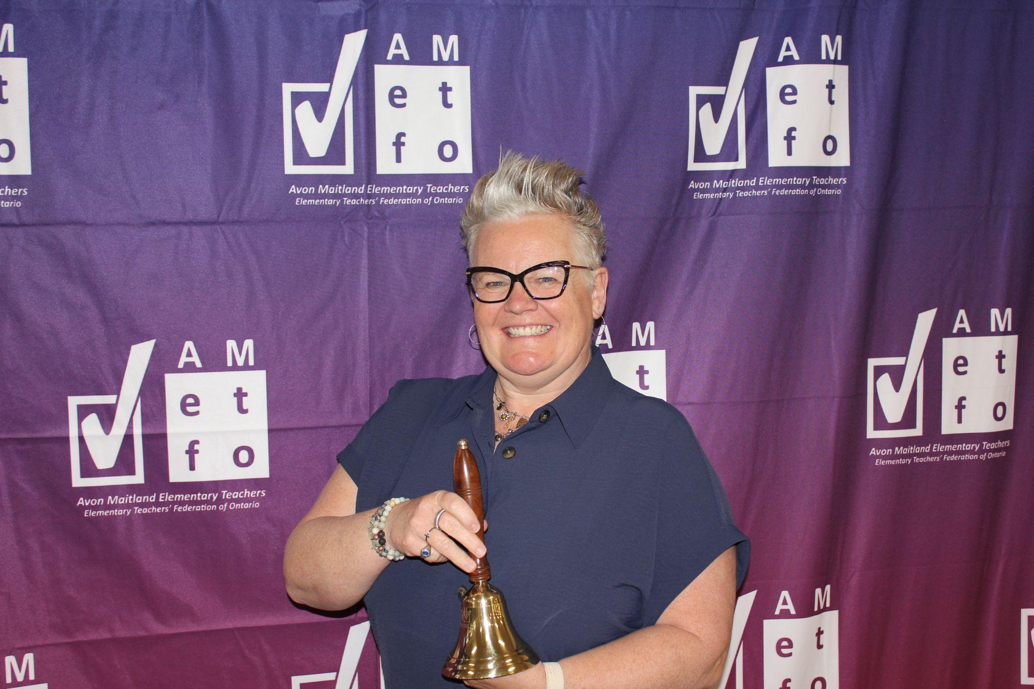  Michelle Nicholson | 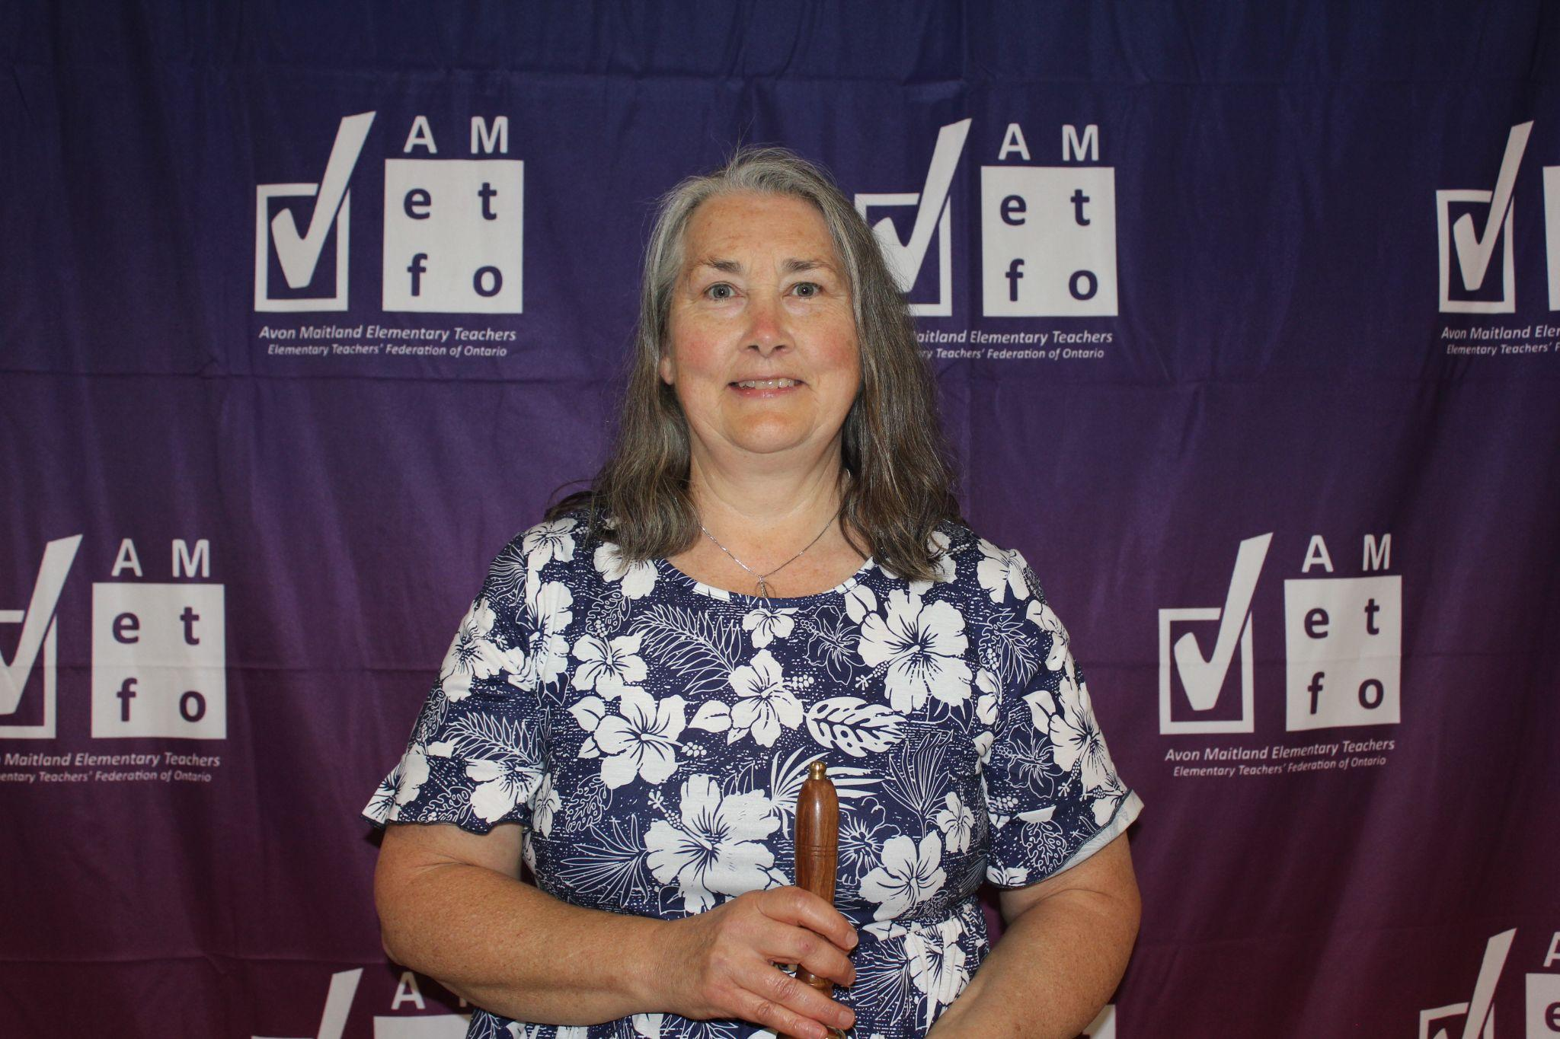  Pauline Howard

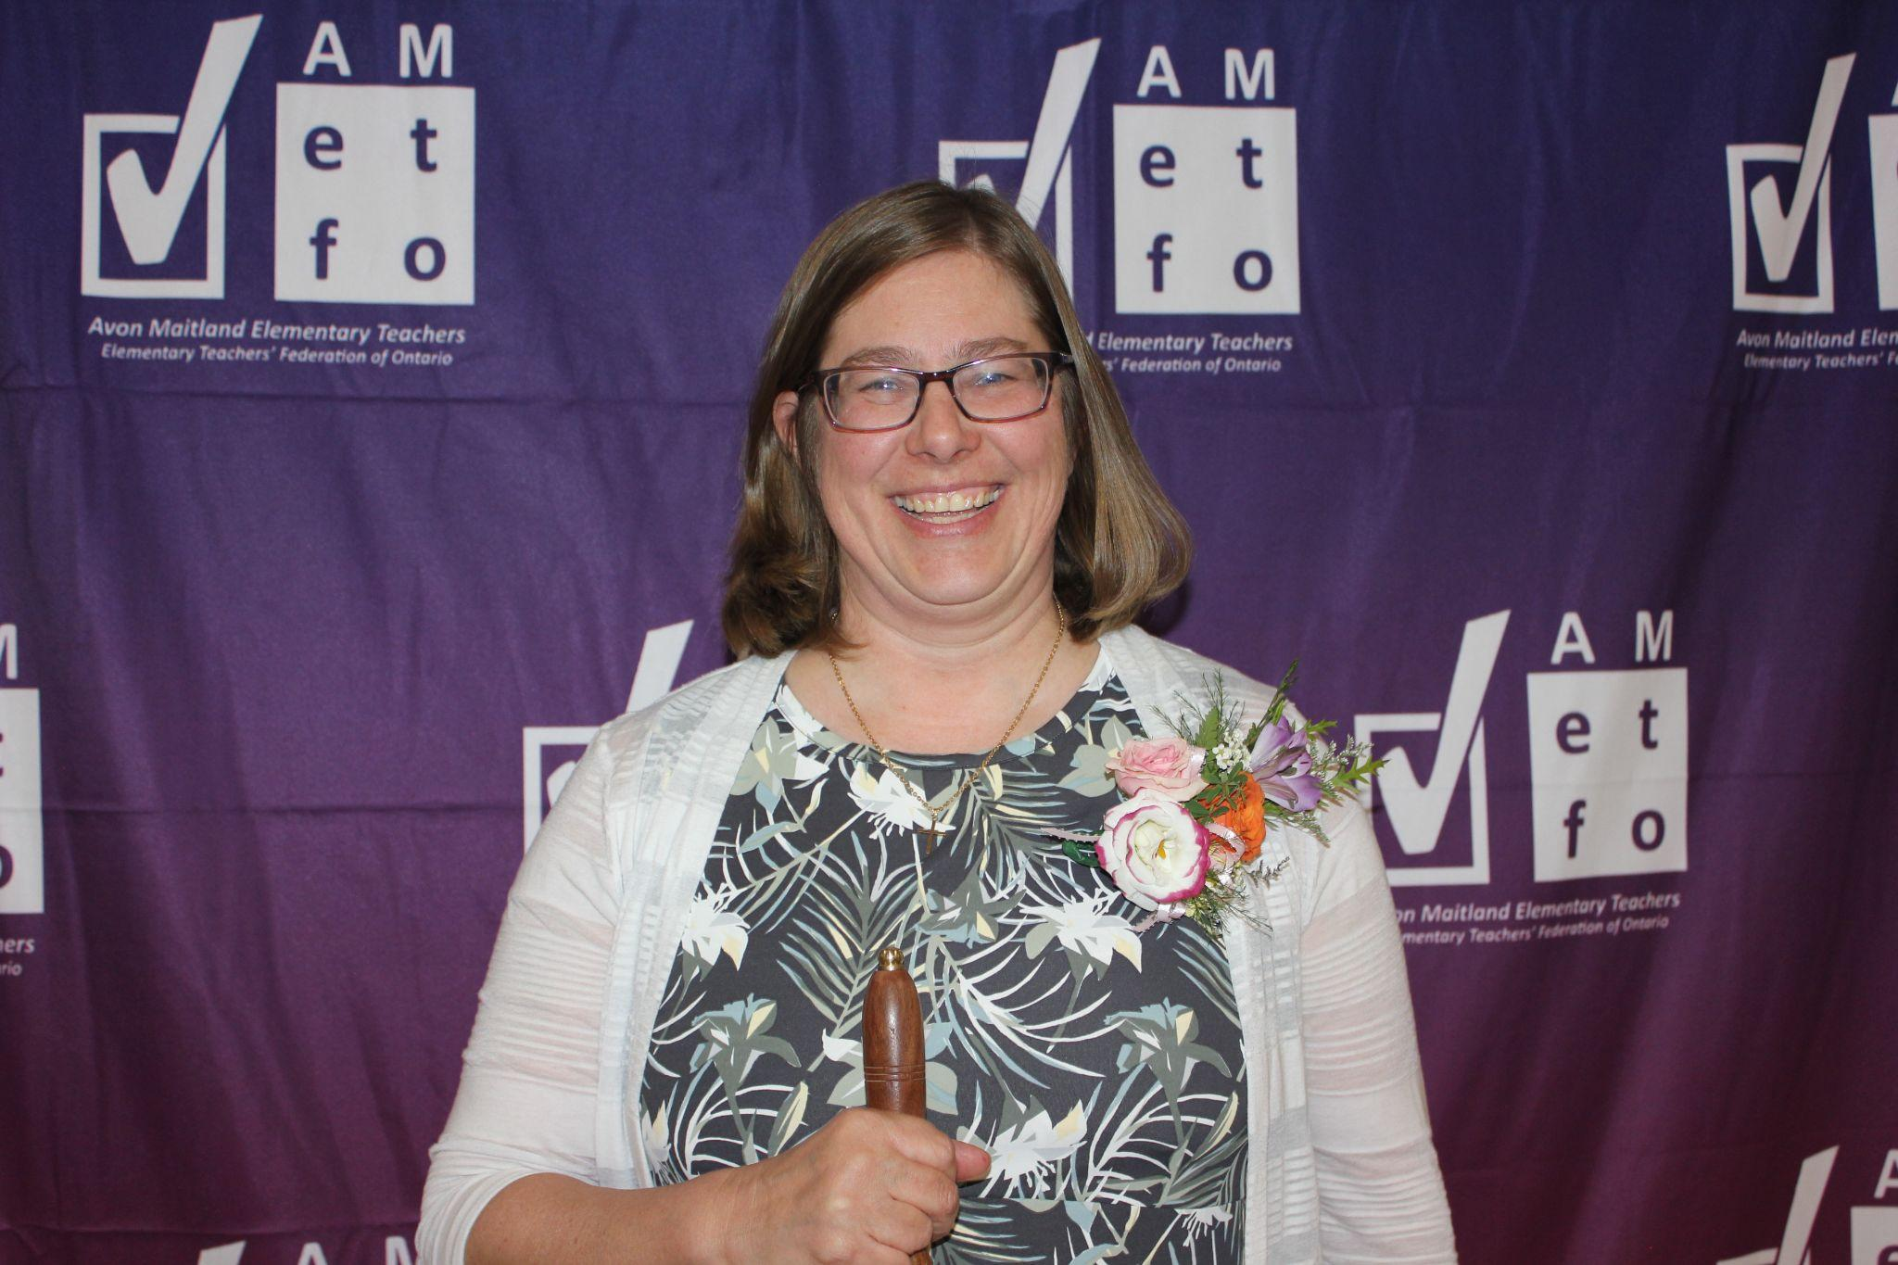  Shari Howson | 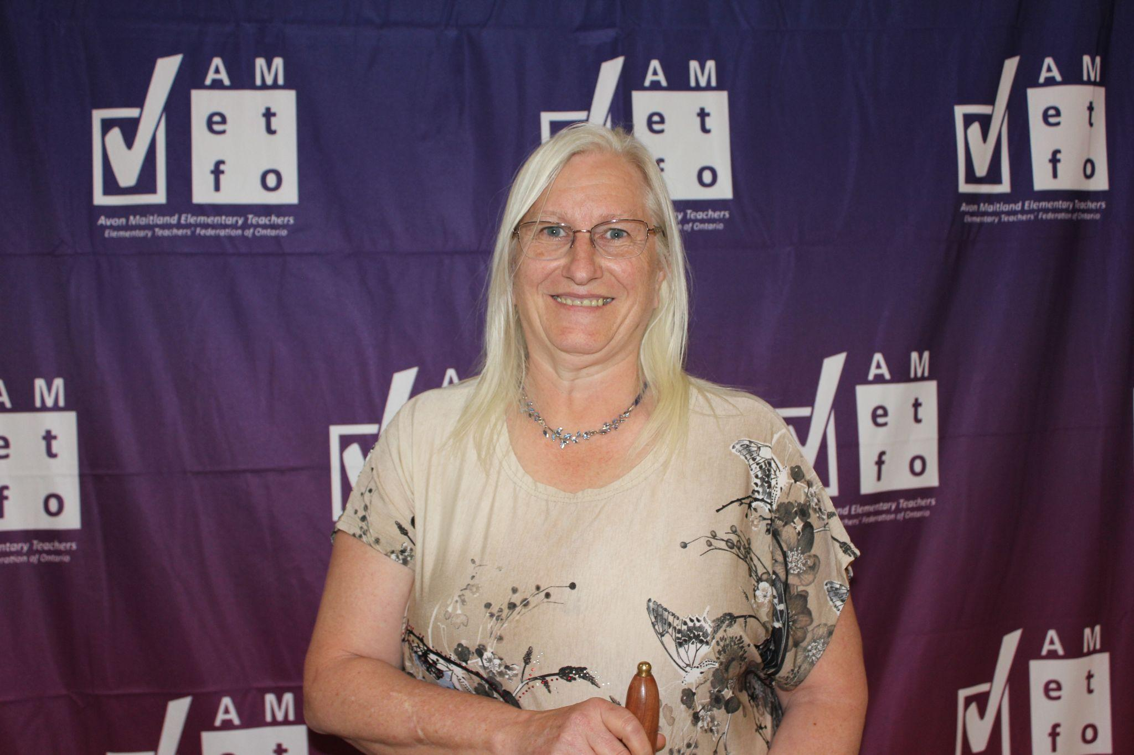  Deb Jagger

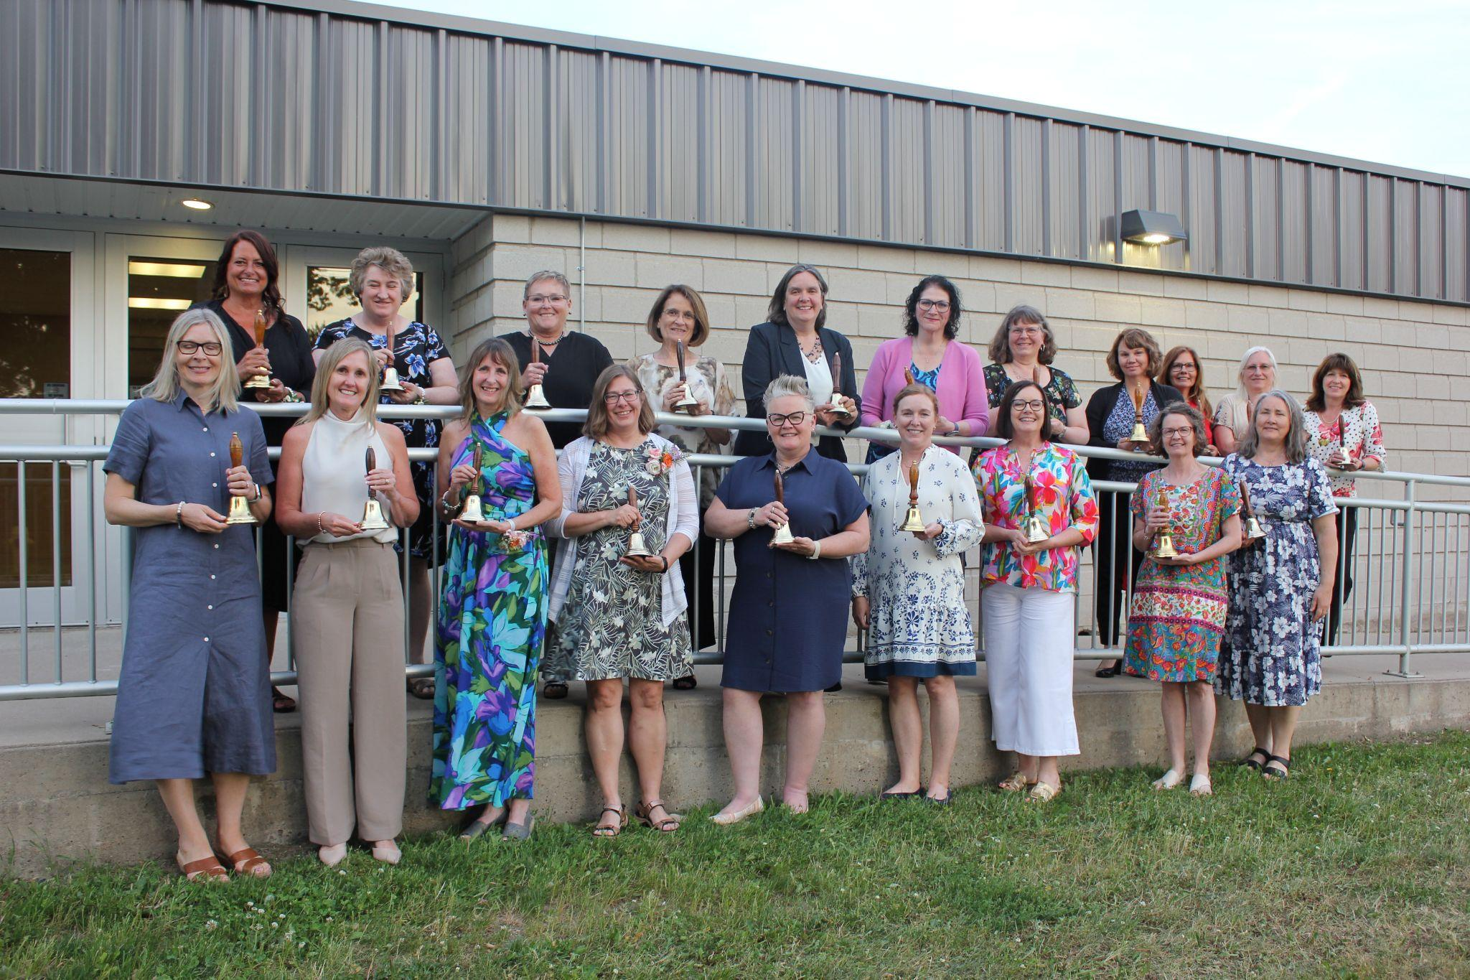

2026 Retirees!

